Task 3: **Design of the Artificial Intelligence System**

Toward the finish of this task, a fast-food requesting framework utilizing versatile application will be done to help any delivery eateries in UMES. Clients can utilize their cell phone to submit their food request in a helpful way and the staffs of the café are additionally ready to utilize the website to refresh the food menu. This framework comprises of customer side and worker side. For the customer side, clients will have the option to see the menu, place request, and checkout from the framework. The client can decide to empower, or handicap message notice sent by the worker. For the worker side, the framework will have the option to let the staff to embed, erase and update the menu. The framework additionally permits staff or proprietor to send messages right away to the clients about any food advancement and furthermore update the food request status and this will be done with Gmail. Additionally, this framework likewise permits the proprietor to refresh the status of every one of each food request. The last aspect of this system is to communicate with the delivery vehicle. This will be done by Gmail API ,Raspberry PI, and a Telemetry. The following are a portion of the modules of proposed framework.

**Client Enlistment and Login Module**

This module contains client's data, for example, client telephone number, name and other data identified with that client. The entirety of this data will be put away in the Firebase.  This is important because based off the data you collect you will be able to keep record on your customer . For this case by you have an information on the customer they won’t have to log into the account every time they open up the app or put in the information every time they try to check out. In figures 1 below show your information is stored inside of Firebase.

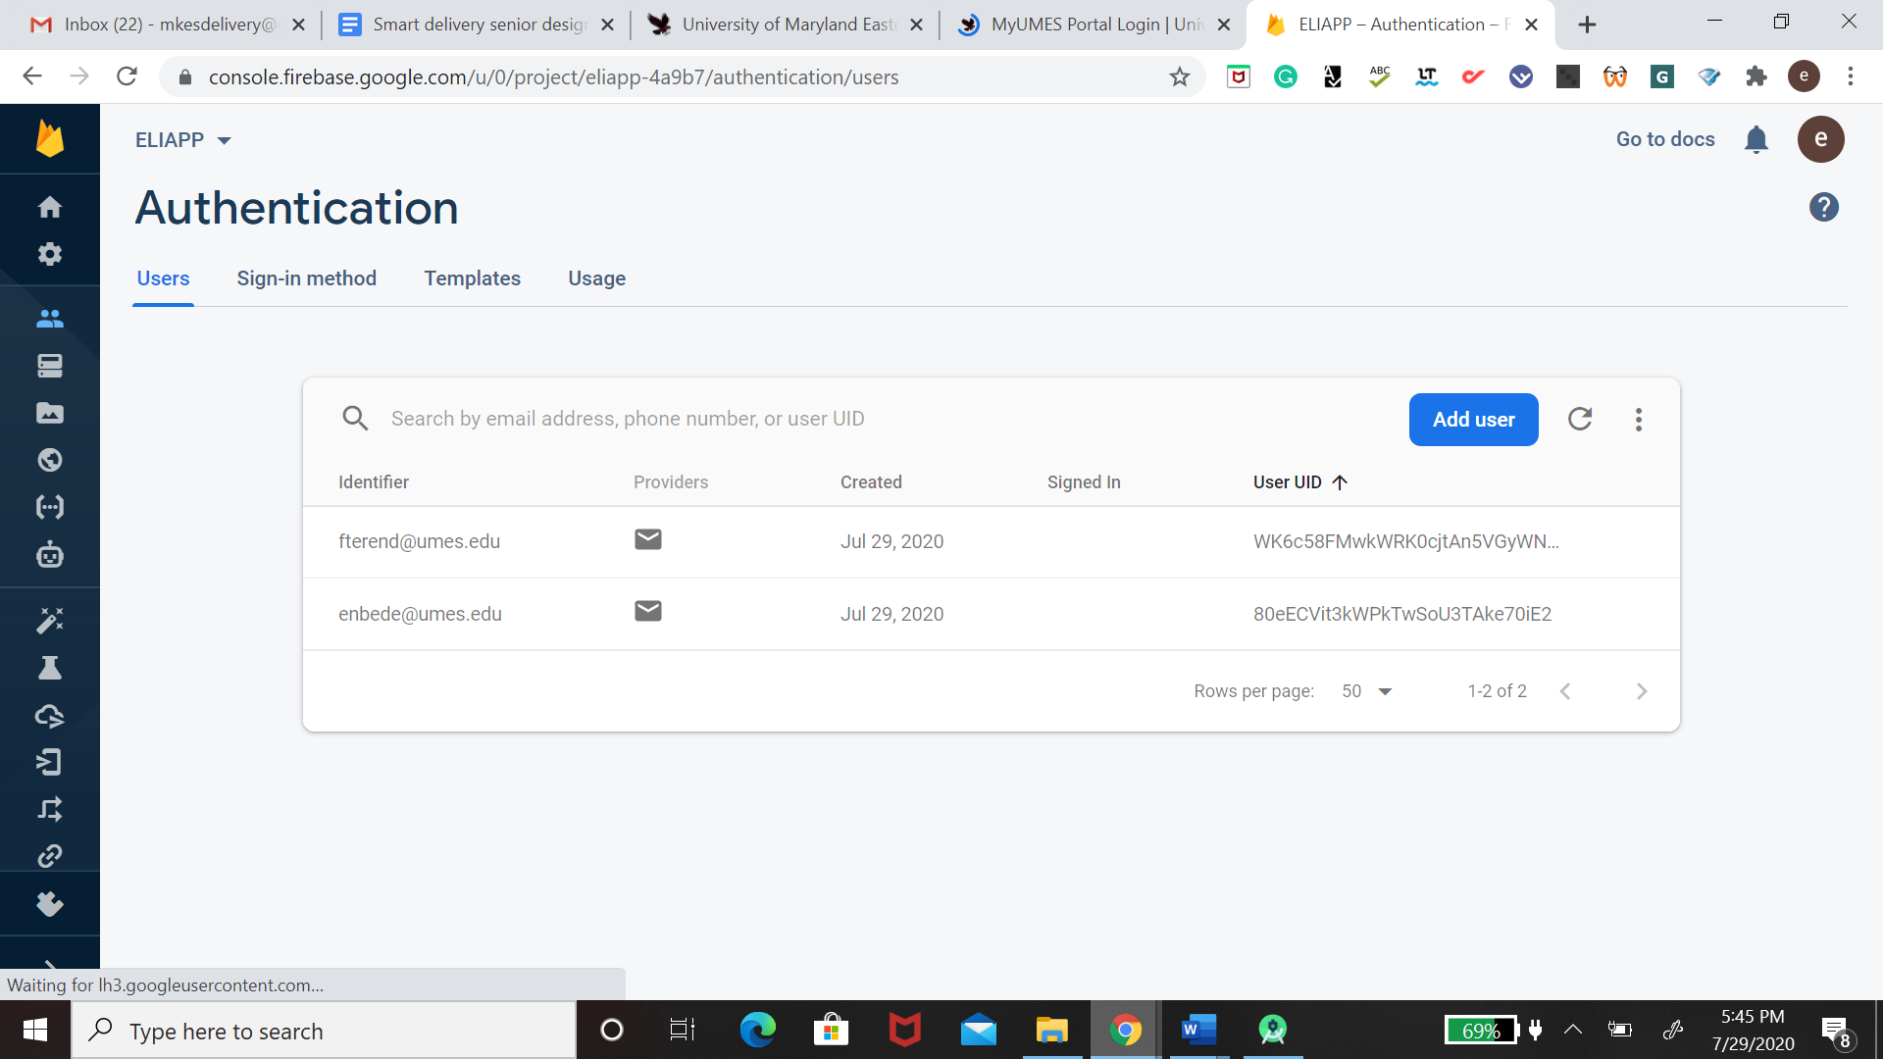

Figure 1 Phone Login In Firebase

**Client Confirmation Module**

This module just permits legitimate client to enter the application. It gives a security which to guarantee that solitary substantial client can utilize the application.  All this will be done in the beginning stage of the application once the customer is logging in.

**Portable Requesting Framework Module**

This module requires café clients to utilize their cell phone to enlist for a record to login to the framework. Clients will be then divert to the menu page where they can explore the food menu. Clients would then be able to choose their food, place into the food truck, audit their request and put in their request. Figure 2 displays a login page. The reason behind this is so no one can assess the client information, and they will get verification from the database.

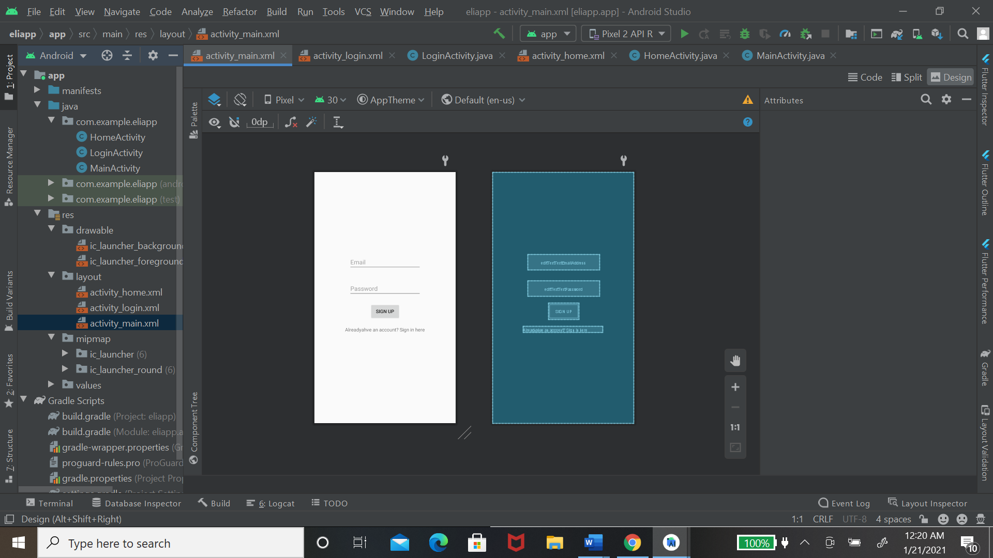

Figure 2 Security page

**Menu Data Module**

This module permits clients to pick a wide assortment of cheap food through a client

cordial menu interface. The information that is stored inside the database about the menu will be coming from the website. This is done by connecting the Firebase database with WordPress API. From there you will be able to extract the information about the website. You will see the data being a store in figure 3.

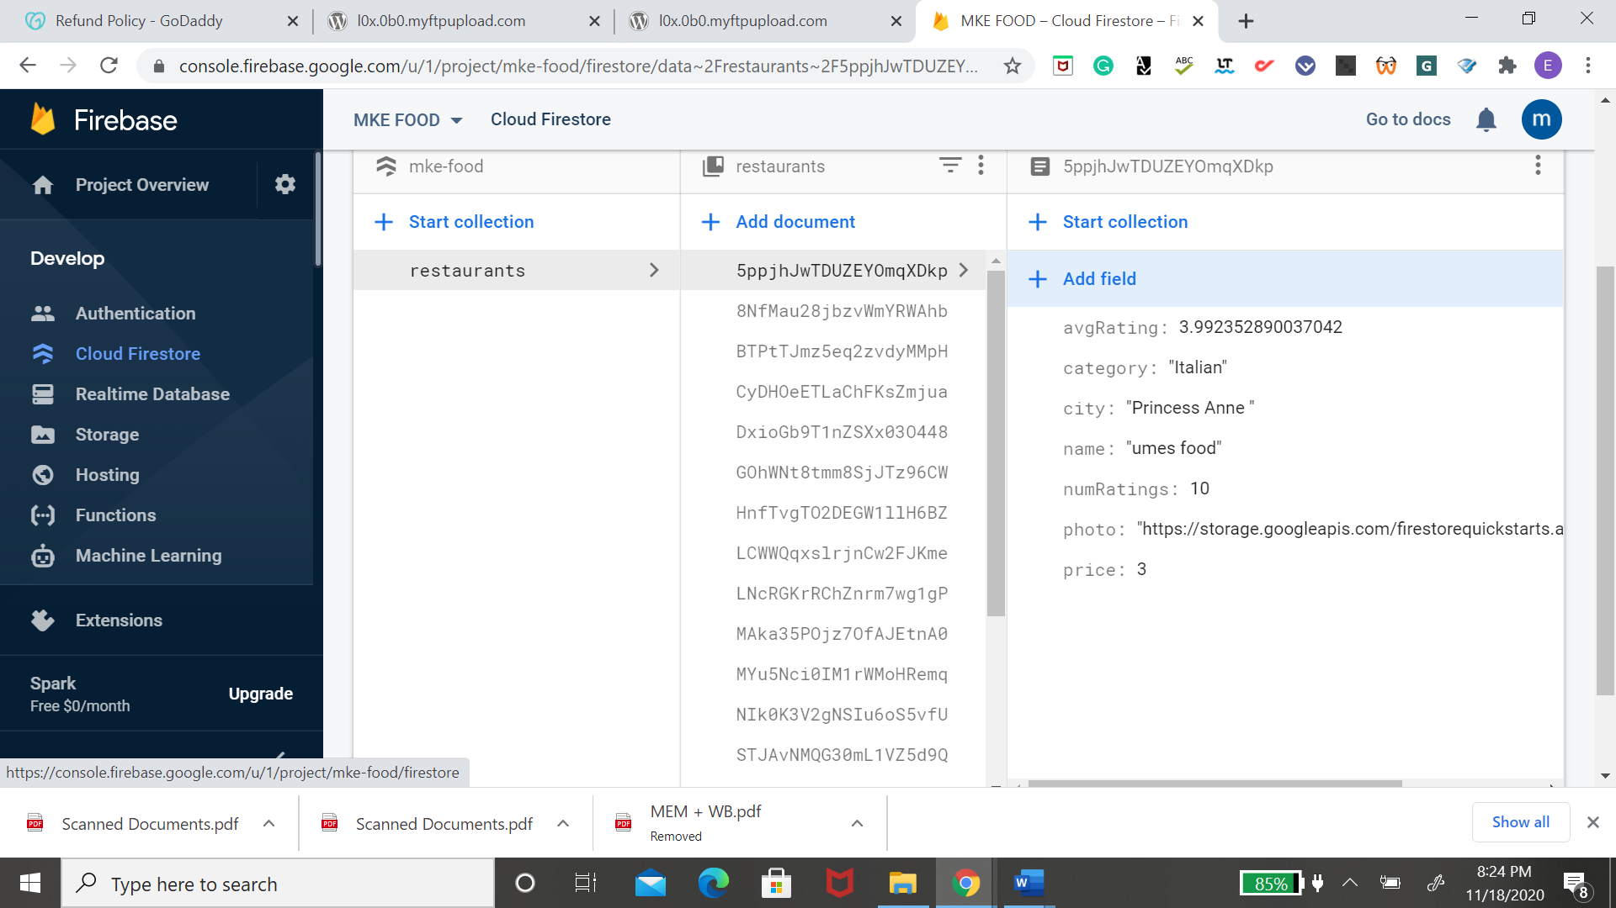

Figure 3 menu in firebase

**Food Cart Module**

This module permits client to see the thing that they request. All the food cost will be summarized and show to the client in a graphical UI. Client is likewise ready to erase the request in this module. It will also be able to give the client a sales tax base on whatever food they are adding to the cart. This is based on whatever state the restaurant is in. Figure 4 shows an item inside the cart with the tax added to it. It also shows an option to delete the item inside the cart.

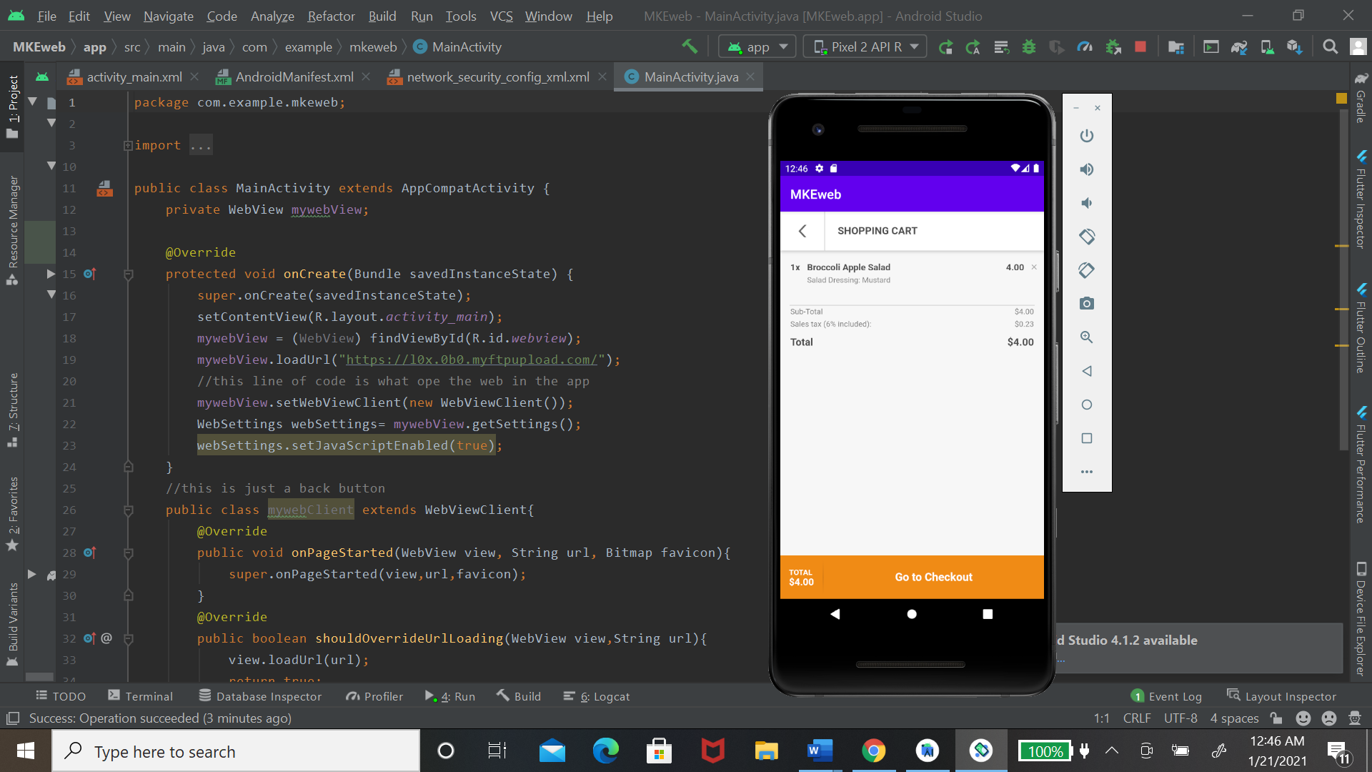

Figure 4 shopping cart

**Request Recovery Framework Module**

This module is to be utilized by the restaurant staff where staffs can recover request from the information base which the requests will be shown in the graphical interface.  In the admin application, you will be able to accept or decline any order. The admin application is a WordPress plug-in. So, there are many limitations to it. Which I will discuss more later on but in figure 5 below shows the staff excepting the order.

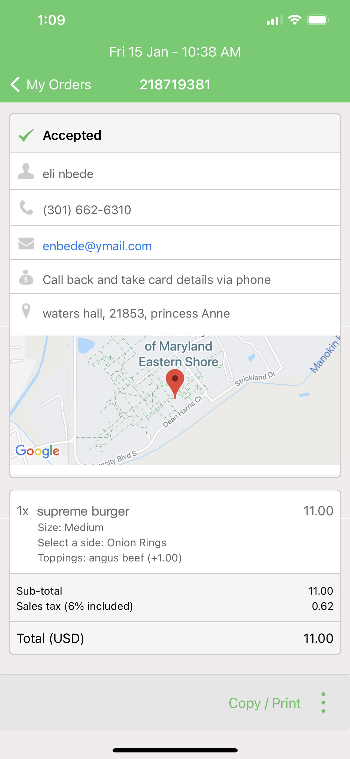

Figure 5 admin recovery

**Website Control Framework Module**

This module is to be utilized by the client which is the eatery proprietor. The proprietor can update the freshest food menu subtleties, for example, value, name, subtleties of the food and photograph with a graphical UI and show to the client. This page is only for the owner of the restaurant. Whatever changes made on this page will also be made on the client application. Because of the connection with the Firebase database whatever change that is made on the website that affects the application will be saved in the database. Figure 6 and 7 display the control panels for the website.

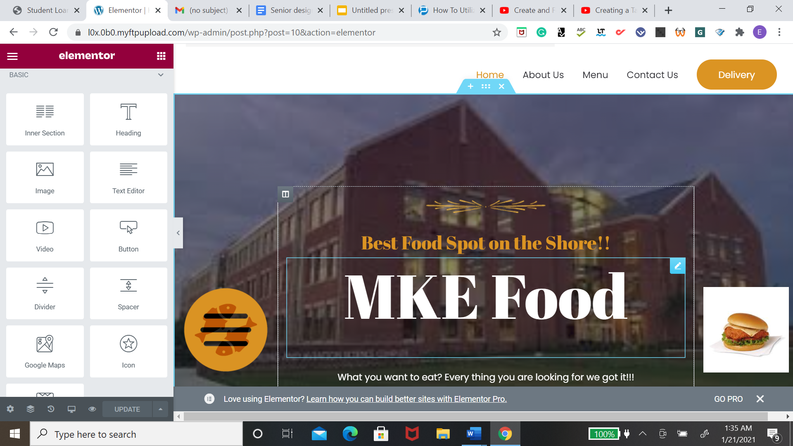

Figure 6 edit elementor

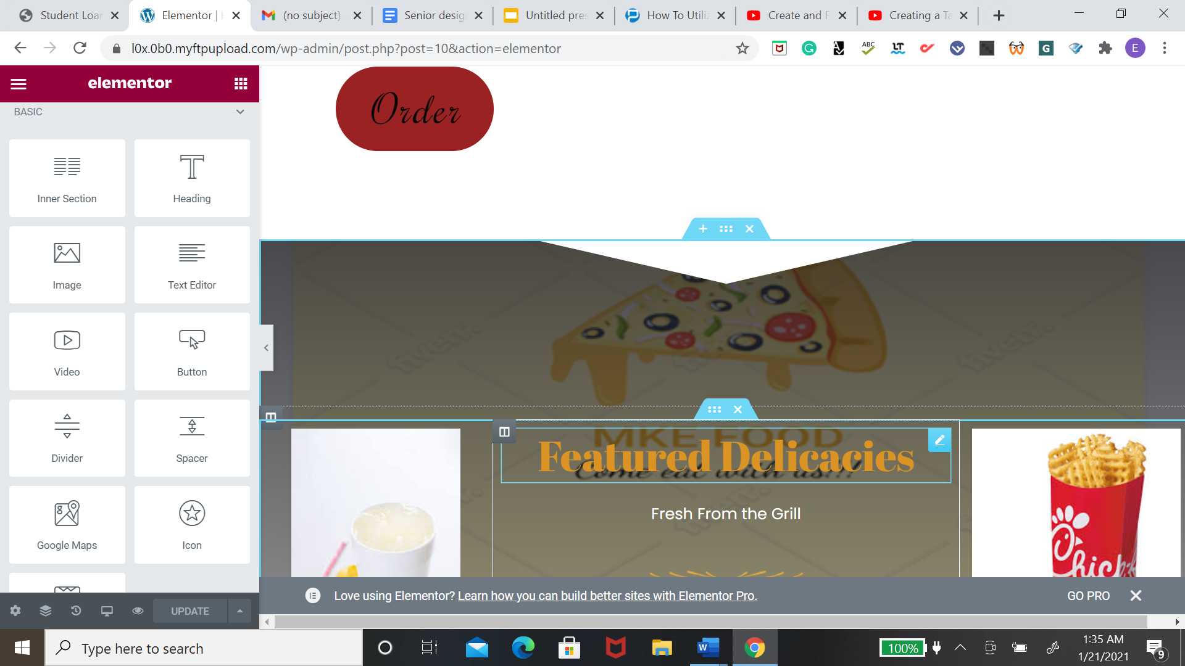

Figure 7 edit elementor

**Search Food Usefulness Module**

This module permits the clients which are the clients to utilize the web index module gave in our framework to look for their food. This element is significant as it spares the client time and furthermore helpful for them. Figure 8 shows how the search menu was made.

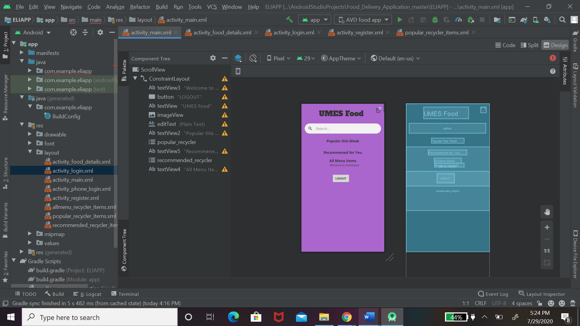

Figure 8 search

**Message Warning Framework Module**

This module permits the staff/proprietor of the eatery to send message to the clients, for example, new food or food advancement. Client can pick if to get to get news from the worker.  Because of the limitation, the admin app has the staff will not be able to send messages from the app. The communication between the client and the staff will be done through email. So once the order is complete the email will be sent to the client and let them know. The option of having the communication being done through the admin app was taught on but with the word press plug-in, there were so many limitations to this app. Figure 9 shows an email being sent to the customer after it was excepted from the ministration app.

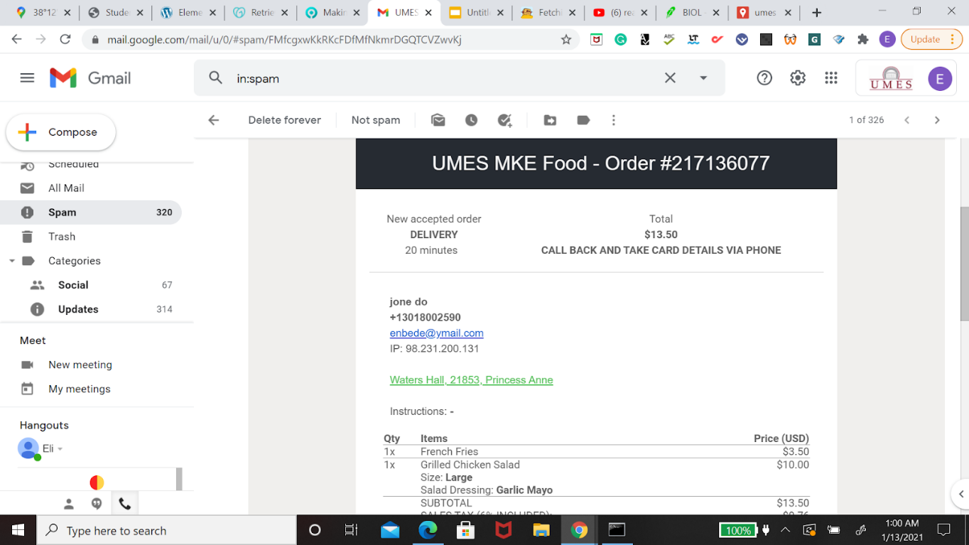

Figure 9 message

**Request The Executive Framework Module**

This module permits the staff of the café to oversee and refresh the requested status with the goal that clients will be ready to know whether their food is set or still in measure. In the admin application, the staff will be able to review all orders that are coming in and all the decision that was made on these orders. They are also able to send an SMH to the printer. They will also be able to manage the account from this app for example by clearing all orders that came through that day. Figure 10 displays all the activities the staff will be able to do.

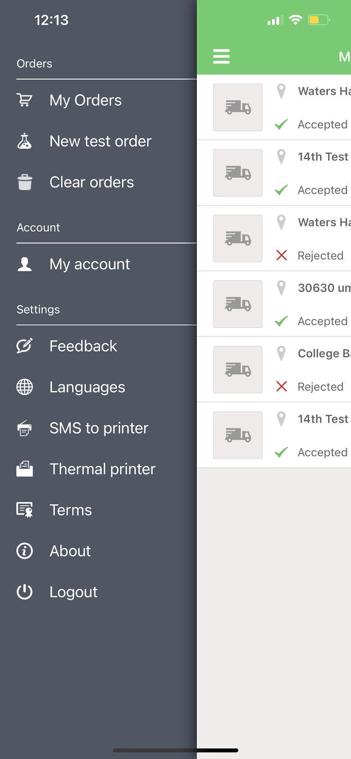

Figure 10 admin app

**Installment Entryway Module**

This module permits the client to make their food request installments by utilizing PayPal. WordPress offers a plug-in For the payment method, but the free version has a limitation. If you want to add PayPal to your website you will have to pay for the premium version. If you’re using the free plug-in the client will be able to call and place in the order.

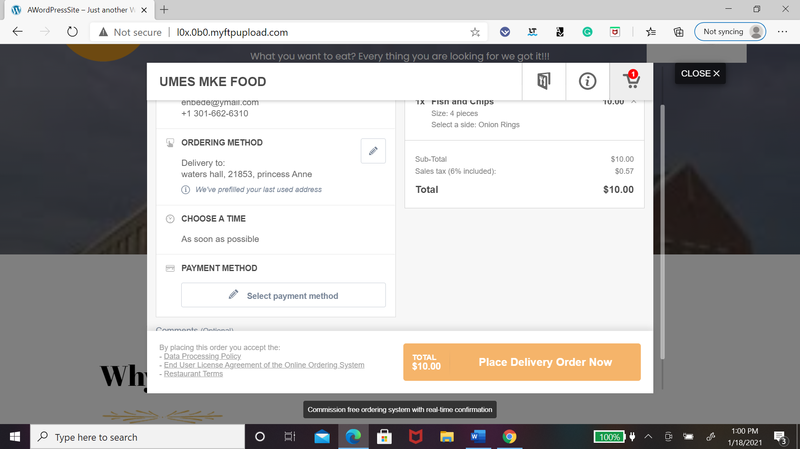

Figure 11 payment method

**communication**

One of the most important parts of the system is the communication between the Client application and the vehicle. This problem is going to be solved by a Raspberry Pi. Since the admin app is not able to communicate with the customer the data is being sent straight to Gmail. To fetch the data that is to need to be sent to the vehicle the raspberry has to communicate through Gmail. This would be done by connecting your raspberry to the same Wi-Fi as your Gmail. The next step is to extract the information with Gmail API. Figure 12 shows the code that was used to connect to Gmail and raspberry and the next figure 13 will show a successful connection. After the data is fetched it will be saved to a folder. Where the pi will be able to call the information and send it to the Telemetry. The process will be displayed in figure 14.

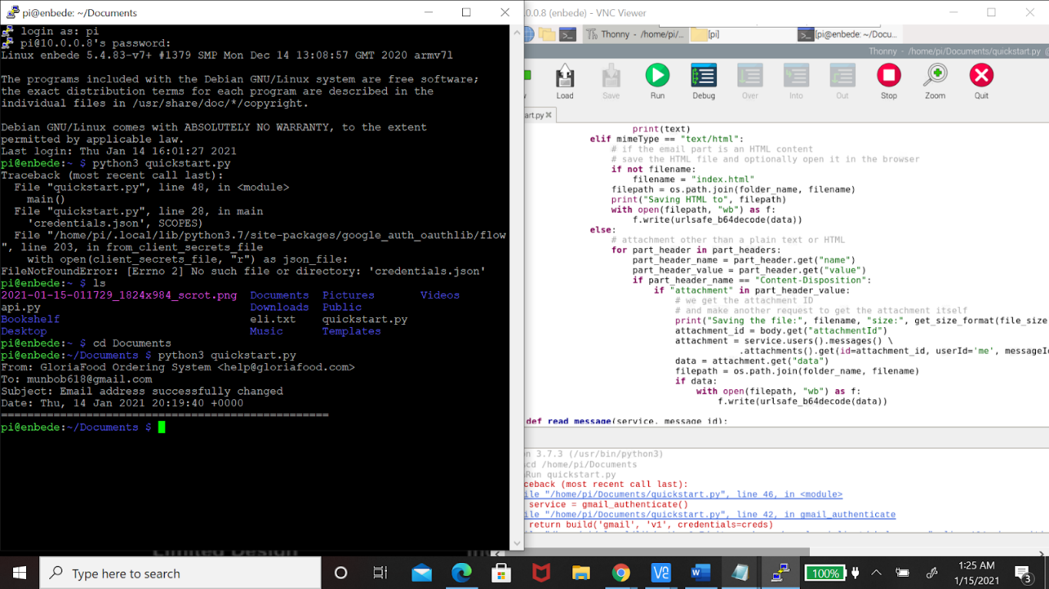

Figure 12 code to get gmail

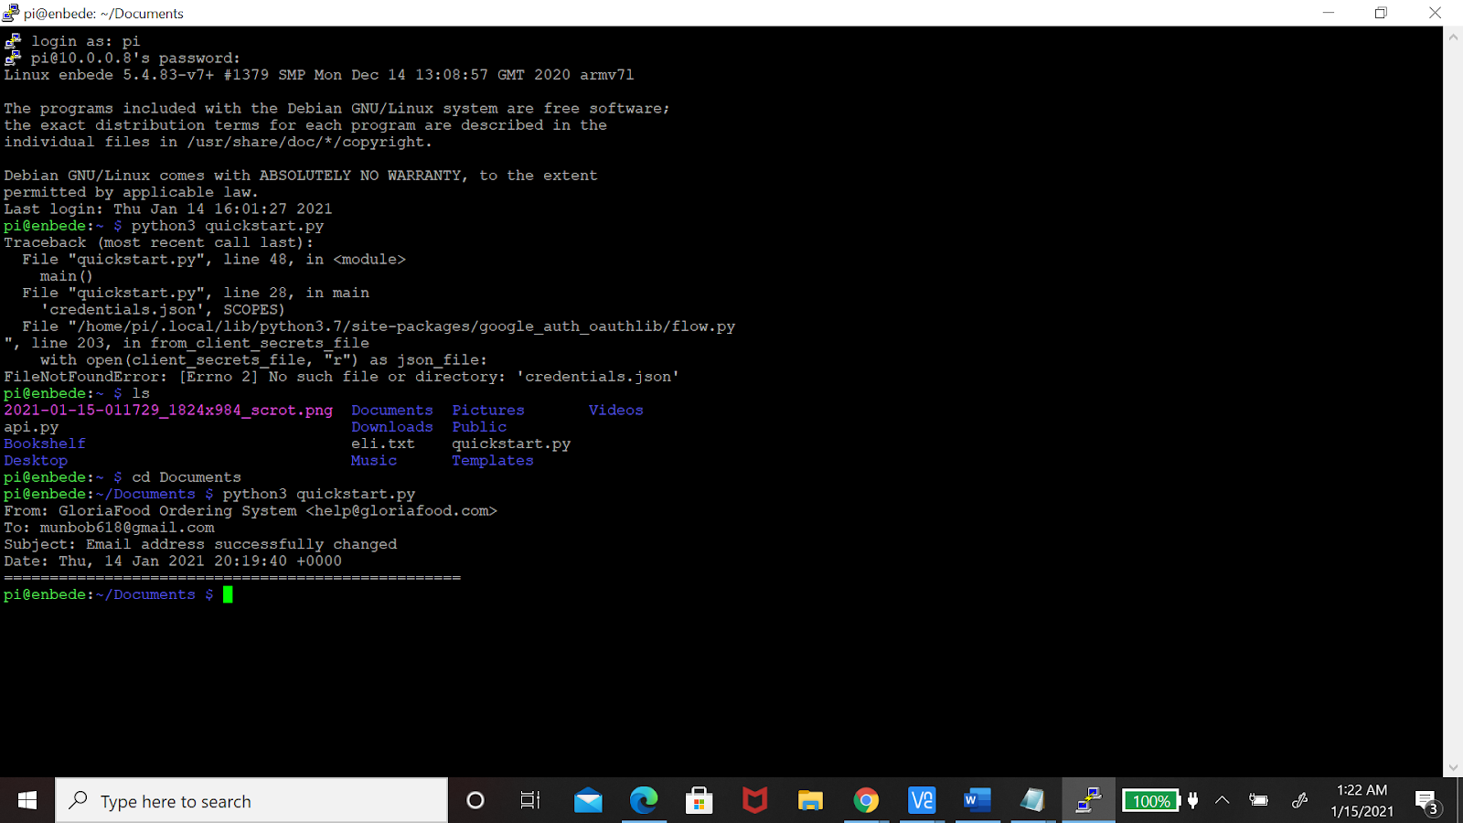

Figure 13 communication with Gmail

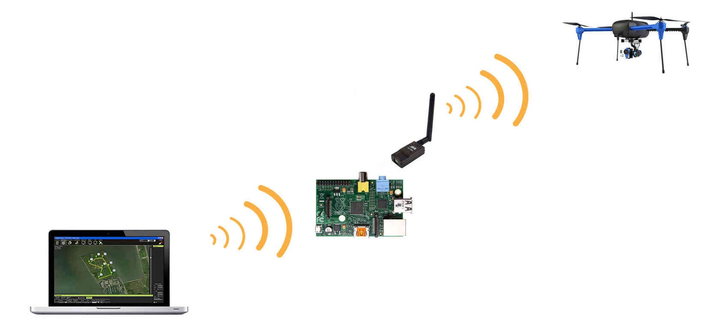

Figure 14 communication to the telemetry

# Functional Requirements

**Programming**

* Front End : Android Studio Improvement Pack, Android SDK and Android Virtual
* Raspberry pi
* Back End : Firebase
* Java programming language is utilized to build a cheap food requesting framework utilizing
* WordPress website
* Gloria Food for admin app

Portable application with the assistance of Android Studio Improvement Unit. Android SDK is an apparatus that empowers engineers to make a portable application for Android Working Framework while Android Virtual Gadget Chief gives a UI to the designer to test the application. For the backend, Firebase will be utilized to store the information base and all the information will be put away in JSON design. Firebase additionally uphold continuous information base. Moreover, all the reports outline, for example, Movement Graphs and Use case chart are made by utilizing the Visual Worldview People group release.

Client Enrollment Module

* The framework will not permit a copy account.
* The framework will just permit fruitful enrollment after all the required
* the data is totally filled.
* The framework will store the data into the Firebase after effectively enrolled.

Client Login Module

* The framework will permit enrolled client with the right telephone number and secret key to log in to the application.
* The framework will have the option to show a blunder message when telephone number is invalid.
* The framework will have the option to show a blunder message when the secret word is mistaken. In figures 15 below shows how the register page is going to looked

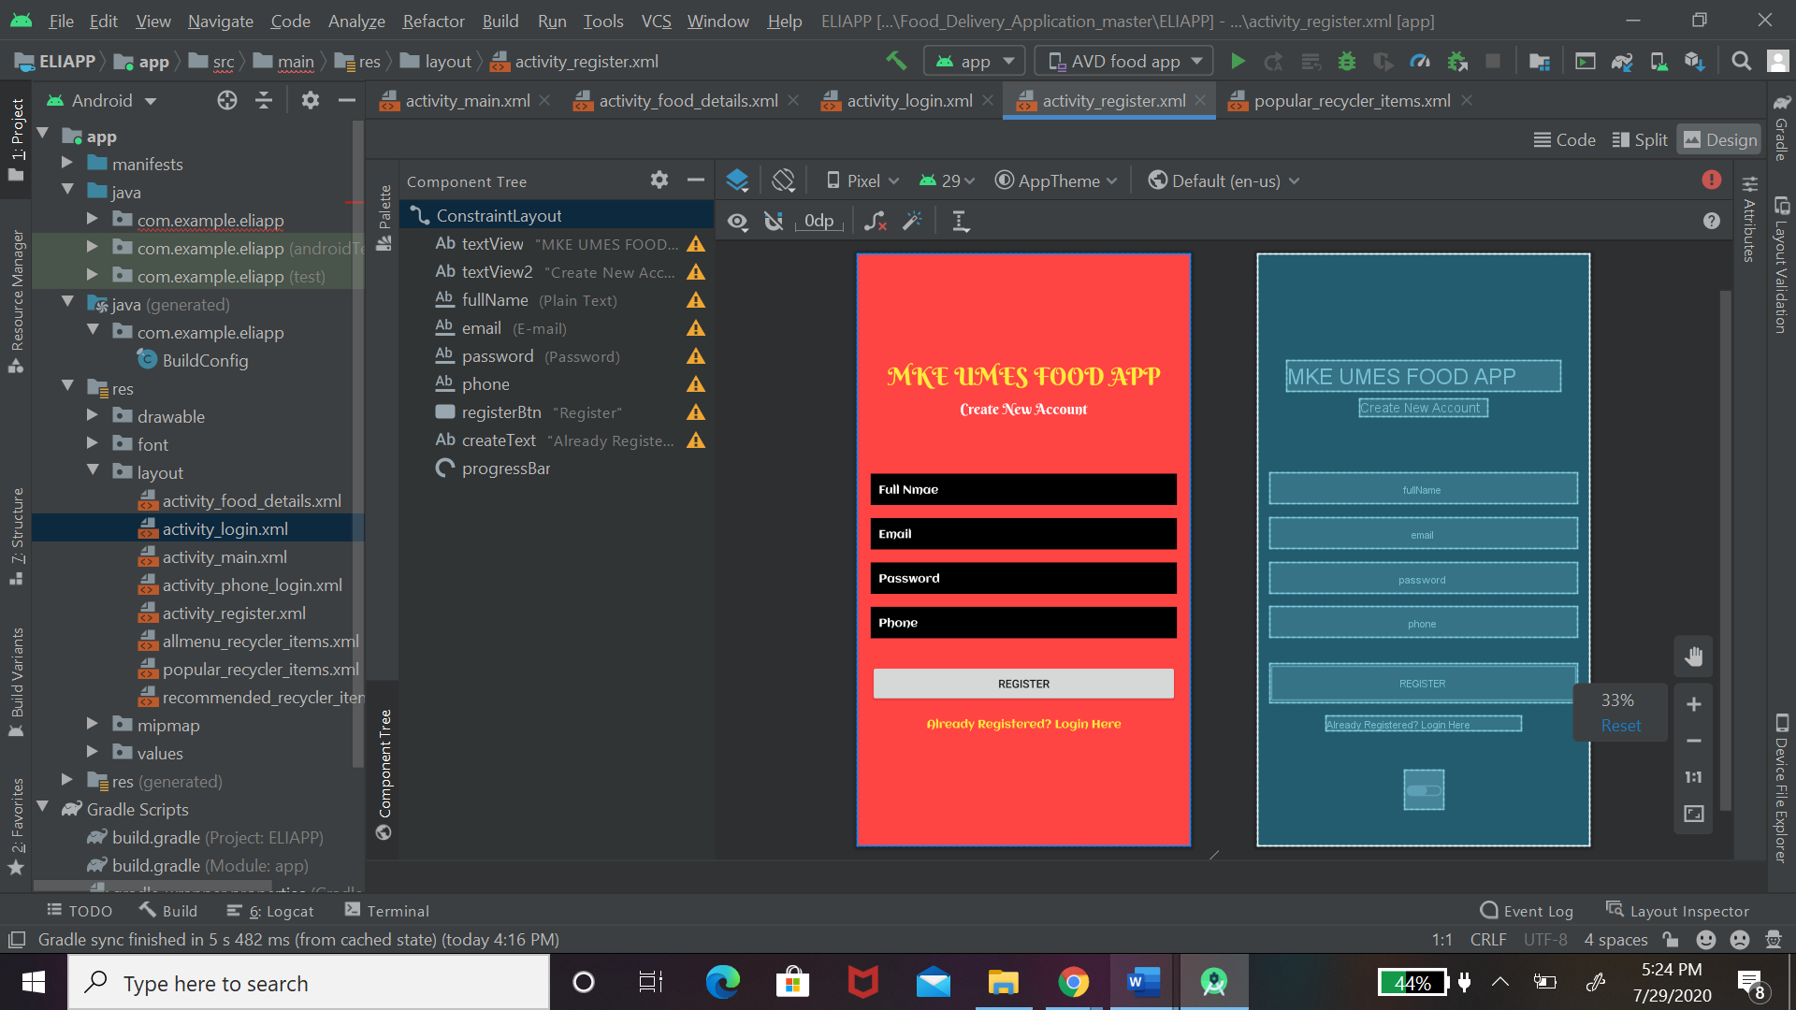

Figure 15 registration

**Proprietor Login Module**

* The framework will permit just enlisted proprietor with right telephone number and secret word to log in to the application.
* The framework will have the option to show a blunder message when the telephone number is invalid.
* The framework will have the option to show a blunder message when the secret word is off base. In figures below shows the flow chart of the background on the one in the register page
* The flow chart in figure 16 shows the relationship between the login interface. If the user information is successful they will be prompt with the homepage but if not they will be prompt with an invalid message

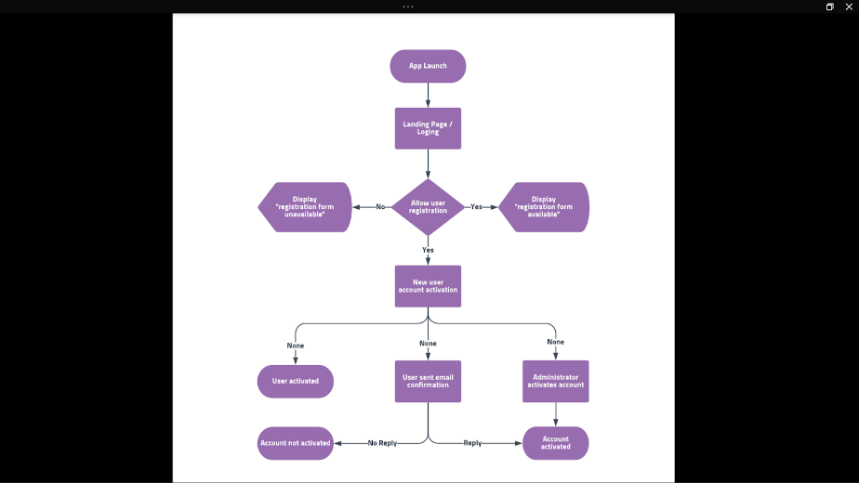

Figure 16 flow chart for registration

**Requesting Framework Module**

* The framework will permit clients to put request by means of their cell phone by introducing the application under web association.
* Menu Data Module
* The framework will show all the food data, for example, value, name, and portrayal to the client. In figure you will be able to see how the main menu detail.

**Food Cart Module**

* The framework will permit the client to see all the food that they chose.
* The framework will show the food put by the client regarding food name, amount, cost of everything and the absolute cost.
* The framework will figure out the complete cost of the food requested by the client.
* Search Food Usefulness Module
* The framework will permit the client to utilize the web crawler module to look for their ideal food.
* The framework will just show the particular food entered by the client by means of the internet searcher module.
* The menu on the website and the client application are the same this is why figure 17 display the website menu.

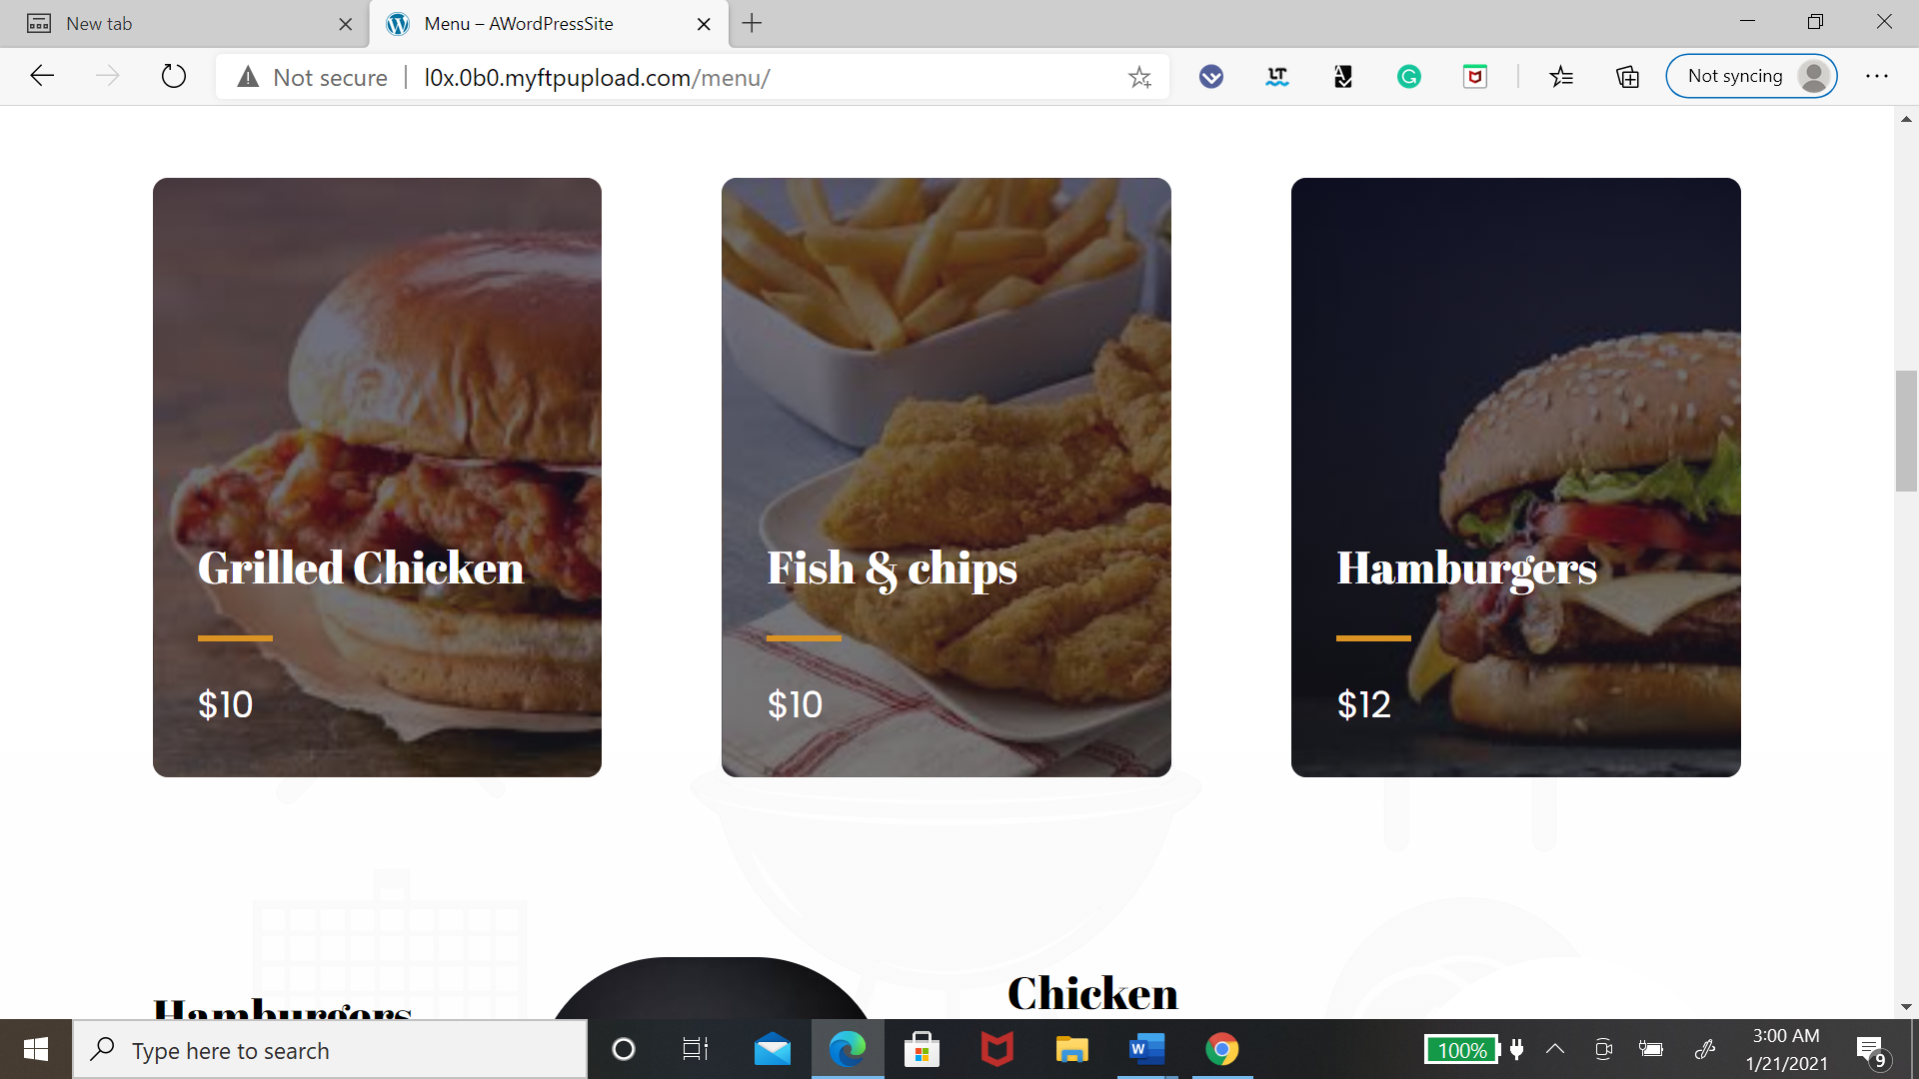

Figure 17 website menu

**Installment Payment Module**

* The framework will permit the client to make installments through PayPal installment strategy. This function will only work if the owner purchases the premium plug-in, but the figure below displays how it will look.

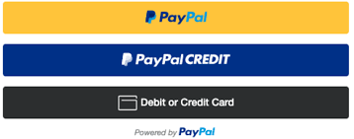

Figure 18 PayPal

**Message Notice Framework Module**

* The framework will permit the proprietor to send any kind of message warning to their client.
* The framework will permit the client to get the message quickly after the proprietor sends the message.
* The framework will permit the client to empower or incapacitate the message notice.
* The framework will show all the request data, for example, request date/time and request subtleties in the request status interface.
* The framework will have the option to advise the client whether their request is in progress or finished**.**
* All the communication between the client and the admin will be done through email.

In flow chart below, the owner of the fast food restaurant required to login as a user to perform any tasks. All the menus the board will take care of by the proprietor, for example, add new food classification, erase food classification or update food class. Additionally, the proprietor is likewise mindful to add new food, add food information, update food data or erase food data. Check Request and update request status is additionally done by the proprietor. For clients, they need to join as a client in the event that they are not a current client. From that point onward, they will be diverted to the menu page where they can choose their cheap food, place them into the food cart and checkout. All this activity will be done with three different applications one is WordPress. This will be used to make changes throughout the website and application. The next application will be Gloria food and this is where the staff will be able to accept or decline orders. This is a plug-in that comes in with the website. The last application will be in your Android studio and this is basically where the client application will be on

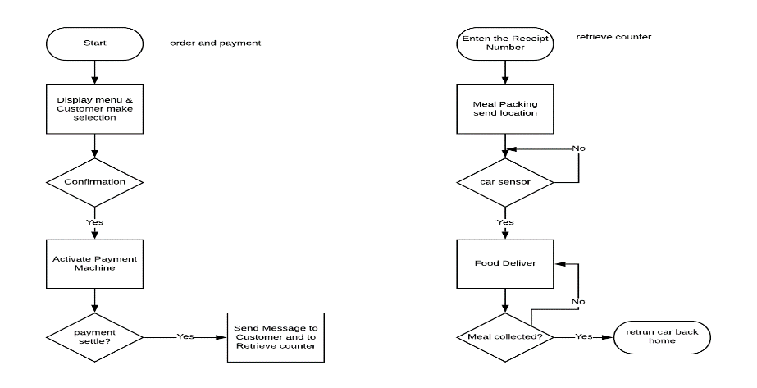

Figure 19 communication between customer and owner

**System Flowchart (Customer)**

In Figure 20 below, this portable application starts with a sprinkle screen. The client is then diverted to the client verification interface. Clients need to join as a client on the off chance that they are not apart. After topping off close to home data on the enrollment page, a menu interface will be shown to the client. Clients need to pick which their request type is. The choice will convey. Clients can either utilize the internet searcher alternative to look for their #1 food or explore through the menu. After wrapping up choosing the ideal fast food, the clients will put in their request to the food truck. Clients can view and check their request in the food truck interface. Prior to presenting their request, clients can leave any additional solicitation or message prior to continuing the installment.

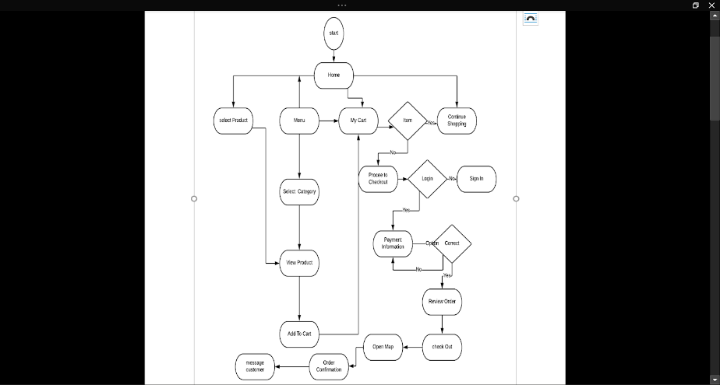

Figure 20 customer flowchart

**Server system Design**

The next Figures 21 below show the framework engineering of fast food delivery system utilizing portable application which covers the 4 regions: serving region, staff's working region, delivery region and far off client region. The framework engineering that will be created in this undertaking would be customer worker design.

* The portable application on the Android gadgets for clients to put in their request.
* The worker on the WordPress and Gloria Food gadget for staff proprietor to track and react to client request and furthermore to refresh the menu.
* The information base for fast food staff to store request subtleties and refreshed menu.
* The remote innovation to help network correspondence.
* Clients can put request (Conveyance) while they are in their home or office.
* All this information will be pass to the car.

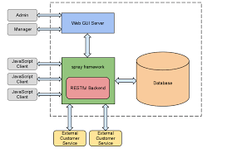

Figure 21 server system

Raspberry Pi and Telemetry communication

* Make Raspberry an access point
* now set ip address
* set up your NAT
* call mavStation (use code MavLink1)
* connecting to 3DR telemetry radio
* the telemetry connection from the laptop to the microcontroller to be able to upload information to the car and have remote access to the vehicle
* telemetry will come in handy when it come uploading /updating information to the server.
* Figure 22 and 23 shows how each telemetry will be connected to there devices.



Figure 22

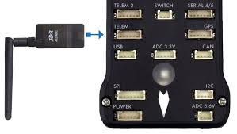

Figure 23

**Website Interface**

Figure 24 for your 25 and figure 26 Will all display different interfaces within the web application. All of this will be done with WordPress.

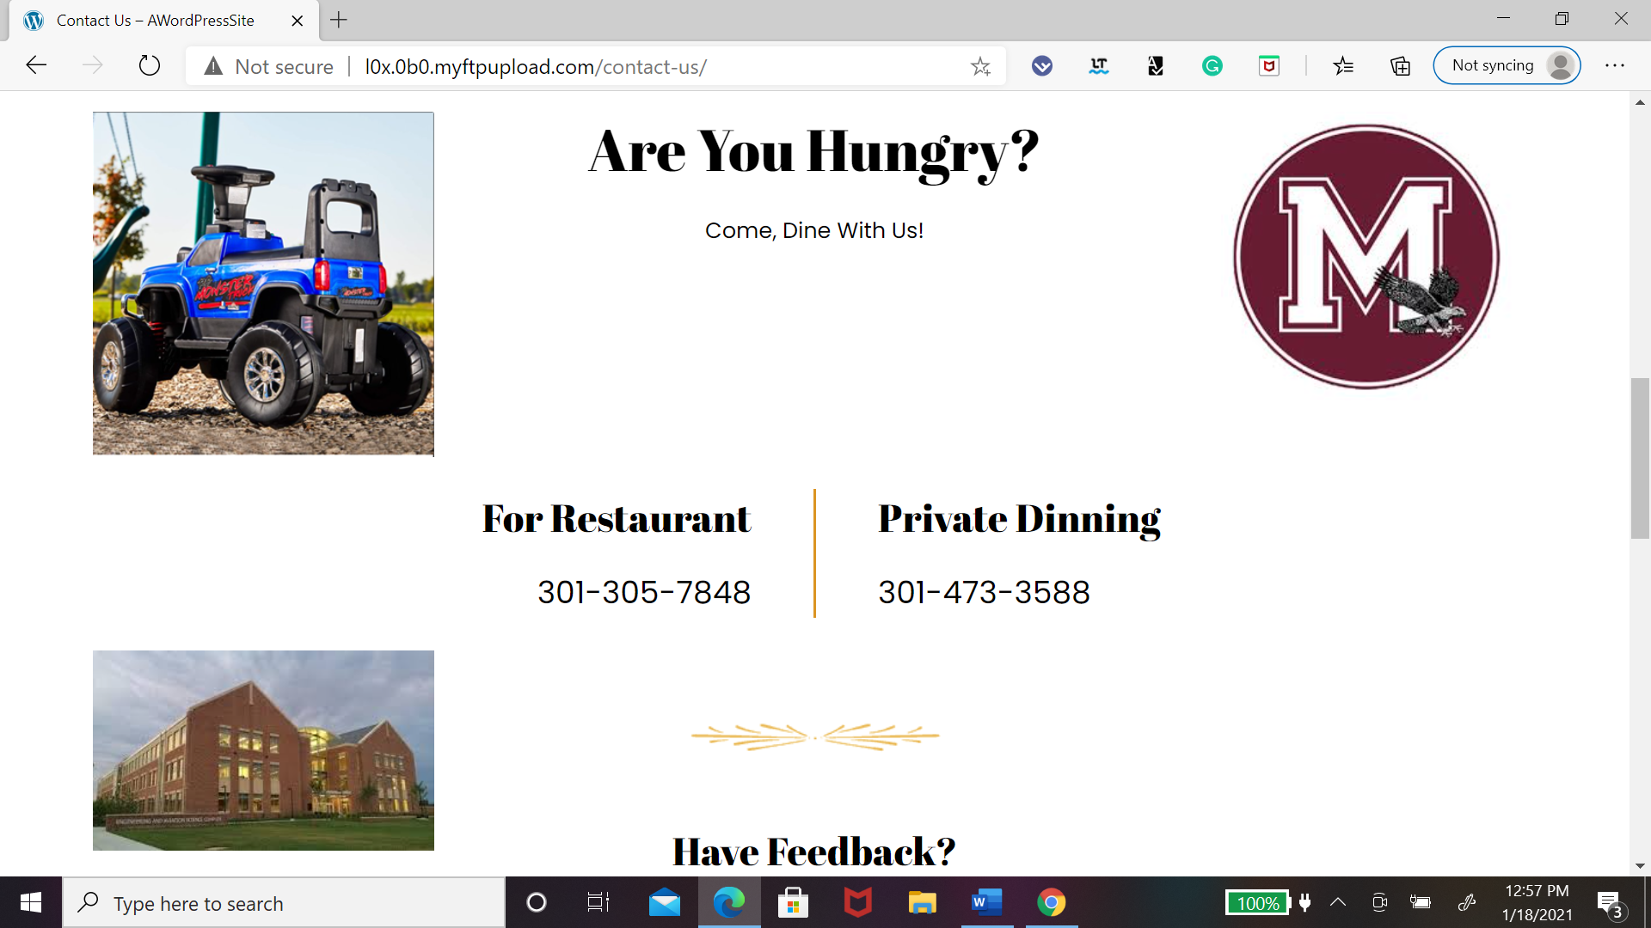

Figure 24 help info

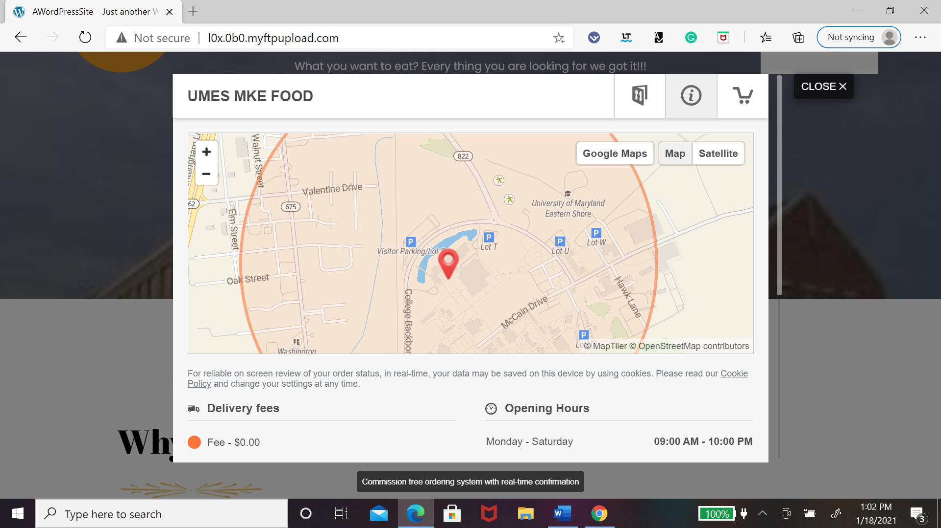

Figure 25 location for delivery

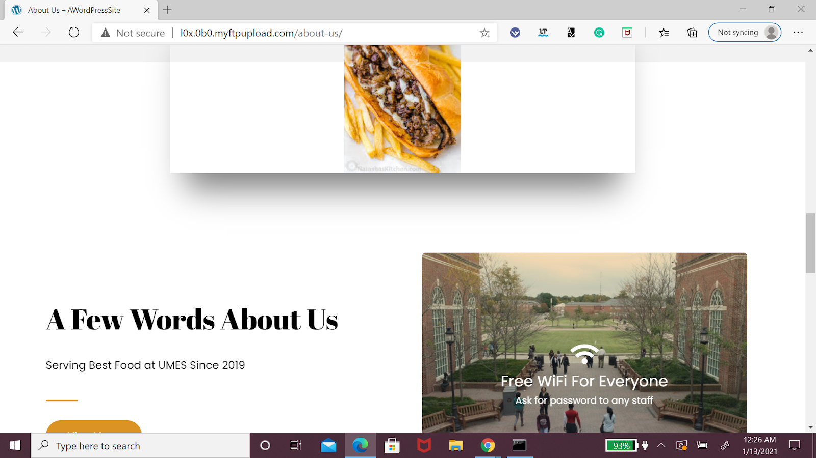

Figure 26 about use

**Conclusion**

At the end of the day, this fast-food restaurant ordering system using the mobile application will help improve the communication between our car the customer, and the owner. With the system, the customer can be notified when the order is complete. This eventually will help speed up the process. Furthermore, the owner will be able to modify anything they want to on the app with the server-side. What's more, this framework likewise gives help to the client as it contains the internet searcher choice where the client can spare their time by utilizing it. All these different frameworks would be incorporated with Raspberry Pi, so it could complete the system. By working with all these systems I was able to learn how if one piece of information is not communicating well the whole system would not function.

Appendix

1. Source Code.
2. Source Code of Phone Login

package com.example.umesfoodapp;  
  
import android.content.Intent;  
import android.os.Bundle;  
import android.text.Editable;  
import android.text.TextWatcher;  
  
import androidx.appcompat.app.AppCompatActivity;  
  
import com.google.android.material.textfield.TextInputEditText;  
  
import Utils.PassingData;  
  
public class LoginActivity extends AppCompatActivity {  
  
 private TextInputEditText textInputEditText;  
  
 @Override  
 protected void onCreate(Bundle savedInstanceState) {  
 super.onCreate(savedInstanceState);  
 setContentView(R.layout.*activity_login*);  
  
 textInputEditText = findViewById(R.id.*login_number*);  
  
 textInputEditText.addTextChangedListener(new TextWatcher() {  
 @Override  
 public void beforeTextChanged(CharSequence charSequence, int i, int i1, int i2) {  
  
 }  
  
 @Override  
 public void onTextChanged(CharSequence charSequence, int i, int i1, int i2) {  
  
 if(charSequence.length()==10){  
  
 String phone_number = "+91" + charSequence.toString();  
  
 PassingData model = new PassingData(LoginActivity.this);  
 model.setPhone(phone_number);  
  
 startActivity(new Intent(LoginActivity.this, VerificationActivity.class).putExtra("object",model)  
 .putExtra("callingActivity",ActivityConstants.*LoginActivity*));  
 }  
 }  
  
 @Override  
 public void afterTextChanged(Editable editable) {  
  
 }  
 });  
  
 }  
}

package com.example.umesfoodapp;  
  
import android.app.DatePickerDialog;  
import android.app.ProgressDialog;  
import android.content.Intent;  
import android.os.Bundle;  
import android.util.Log;  
import android.view.View;  
import android.widget.DatePicker;  
import android.widget.ImageView;  
import android.widget.TextView;  
import android.widget.Toast;  
  
import androidx.annotation.NonNull;  
import androidx.annotation.Nullable;  
import androidx.appcompat.app.AppCompatActivity;  
  
import com.cepheuen.elegantnumberbutton.view.ElegantNumberButton;  
import com.example.umesfoodapp.SessionManagement.SessionManagement;  
import com.google.android.gms.tasks.OnFailureListener;  
import com.google.android.gms.tasks.OnSuccessListener;  
import com.google.android.material.button.MaterialButton;  
import com.google.firebase.firestore.CollectionReference;  
import com.google.firebase.firestore.DocumentReference;  
import com.google.firebase.firestore.DocumentSnapshot;  
import com.google.firebase.firestore.FirebaseFirestore;  
import com.google.firebase.messaging.FirebaseMessaging;  
  
import java.text.SimpleDateFormat;  
import java.util.Calendar;  
import java.util.Date;  
import java.util.HashMap;  
import java.util.List;  
import java.util.Locale;  
import java.util.Map;  
import java.util.Objects;  
  
public class CheckoutActivity extends AppCompatActivity {  
  
 private TextView selectedDate,deliveryAddress,walletBalance,totalPrice,planPrice,planDays;  
 private MaterialButton selectDate,pay;  
 private TextView category_veg,category_nonveg;  
 private ImageView checkoutImage;  
 private FirebaseFirestore db;  
 private SessionManagement sessionManagement;  
 private long credits = 0;  
 private ProgressDialog progressDialog;  
 Calendar calendar = Calendar.*getInstance*();  
 String currentTime = new SimpleDateFormat("HH:mm:ss", Locale.*getDefault*()).format(new Date());  
 int year = calendar.get(Calendar.*YEAR*);  
 int month = calendar.get(Calendar.*MONTH*);  
 int day = calendar.get(Calendar.*DAY_OF_MONTH*);  
 int no_days,num=1;  
  
 public ElegantNumberButton btn1;  
  
 @Override  
 protected void onCreate(@Nullable Bundle savedInstanceState) {  
 super.onCreate(savedInstanceState);  
 setContentView(R.layout.*activity_checkout*);  
 sessionManagement = new SessionManagement(this);  
 progressDialog = new ProgressDialog(this);  
 progressDialog.setTitle("Wait");  
 progressDialog.setMessage("Doing something");  
 progressDialog.setCancelable(false);  
  
 initViews();  
 no_days= Integer.*parseInt*(Objects.*requireNonNull*(getIntent().getStringExtra("days")));  
 final int per_day= Integer.*parseInt*(Objects.*requireNonNull*(getIntent().getStringExtra("prices")));  
 final int meal=getIntent().getIntExtra("meal",0);  
 planPrice.setText("₹"+ Integer.*toString*(no_days*per_day));  
 planDays.setText(no_days+"Days");  
 totalPrice.setText(planPrice.getText());  
 setDeliveryWalletBalance();  
 category_veg=findViewById(R.id.*checkout_veg*);  
 category_nonveg=findViewById(R.id.*checkout_nonveg*);  
 if(meal== 0)  
 {  
 category_veg.setVisibility(View.*INVISIBLE*);  
 category_nonveg.setVisibility(View.*VISIBLE*);  
 }  
  
  
 selectDate.setOnClickListener(new View.OnClickListener() {  
 @Override  
 public void onClick(View v) {  
  
 openDatePicker();  
 }  
 });  
 //set the maximum range of dabbas  
 btn1.setRange(1, 5);  
 btn1.setOnClickListener(new ElegantNumberButton.OnClickListener() {  
 @Override  
 public void onClick(View view) {  
 num = Integer.*parseInt*(btn1.getNumber());  
 if(num==0)  
 {  
 planPrice.setText("₹"+ Integer.*toString*(no_days*per_day));  
 totalPrice.setText(planPrice.getText());  
 }  
 else {  
 planPrice.setText("₹" + Integer.*toString*(no_days * per_day * num));  
 totalPrice.setText(planPrice.getText());  
 }  
 }  
 });  
  
 pay.setOnClickListener(new View.OnClickListener() {  
 @Override  
 public void onClick(View v) {  
  
 createPayment(meal,num);  
 }  
 });  
 deliveryAddress.setOnClickListener(new View.OnClickListener() {  
 @Override  
 public void onClick(View v) {  
 startActivity(new Intent(CheckoutActivity.this, MapActivity.class).putExtra("callingActivity",002)  
 .putExtra("Sessionid",sessionManagement.getUserDocumentId()));  
 }  
 });  
  
  
 }  
  
 private void createPayment(final int meal, final int num) {  
  
 if(credits >= Long.*parseLong*(totalPrice.getText().toString().substring(1))){  
  
 progressDialog.show();  
  
 final long remaining_balance = credits - Long.*parseLong*(totalPrice.getText().toString().substring(1));  
  
  
 final DocumentReference docRef = db.collection("users").document(sessionManagement.getUserDocumentId());  
 docRef.update("wallet",remaining_balance).addOnSuccessListener(new OnSuccessListener<Void>() {  
 @Override  
 public void onSuccess(Void aVoid) {  
 addSubcription(meal, Long.*parseLong*(totalPrice.getText().toString().substring(1)),num);  
 subscribeToNotification();  
 Toast.*makeText*(CheckoutActivity.this, "Subcription Added!", Toast.*LENGTH_SHORT*).show();  
 startActivity(new Intent(CheckoutActivity.this, MainActivity.class));  
 }  
 }).addOnFailureListener(new OnFailureListener() {  
 @Override  
 public void onFailure(@NonNull Exception e) {  
  
 Toast.*makeText*(getApplicationContext(),"Please try after some time", Toast.*LENGTH_SHORT*).show();  
 }  
 });  
 }  
 else{  
 Toast.*makeText*(getApplicationContext(),"You don't have enough credit balance", Toast.*LENGTH_SHORT*).show();  
 }  
  
 }  
 private void walletTransaction(long deducted, String id)  
 {  
 String currentDate = new SimpleDateFormat("dd MMM, yyyy", Locale.*getDefault*()).format(new Date());  
 Map<String, Object> wal=new HashMap<>();  
 wal.put("date_Of_transaction",currentDate);  
 wal.put("wal_transaction_razor","");  
 wal.put("subscription id",id);  
 wal.put("time_Of_transaction",currentTime);  
 wal.put("amount_deducted",deducted);  
 wal.put("amount_added",0);  
 CollectionReference coref=db.collection("users").document(sessionManagement.getUserDocumentId()).collection("Wallet");  
 coref.add(wal).addOnSuccessListener(new OnSuccessListener<DocumentReference>() {  
 @Override  
 public void onSuccess(DocumentReference documentReference) {  
 Log.*d*(TAG, "wallet updated");  
 }  
 });  
 }  
 private void addorder(final String id, final int num)  
 {  
 List<DocumentSnapshot> documentSnapshots;  
 CollectionReference ref=db.collection("users").document(sessionManagement.getUserDocumentId()).collection("Subscriptions");  
 ref.document().get().addOnSuccessListener(new OnSuccessListener<DocumentSnapshot>() {  
 @Override  
 public void onSuccess(DocumentSnapshot documentSnapshot) {  
 Map<String, Object> order = new HashMap<>();  
 order.put("date", selectedDate.getText());  
 order.put("status", "preparing");  
 order.put("subcription_id",id);  
 order.put("no_of_dabba",num);  
 order.put("time_of_arrival", "14:20:30");  
 db.collection("users").document(sessionManagement.getUserDocumentId()).collection("MyOrders")  
 .add(order).addOnSuccessListener(new OnSuccessListener<DocumentReference>() {  
 @Override  
 public void onSuccess(DocumentReference documentReference) {  
 Log.d(TAG, "order placed");  
 }  
 });  
 }  
 });  
  
  
  
  
  
  
 }  
 private void addSubcription(int meal, final long c, final int num)  
 {  
 String a="Veg";  
 if(meal==0)  
 {  
 a="Non-Veg";  
 }  
  
 Map<String, Object> subcription=new HashMap<>();  
 subcription.put("date_Of_activation",selectedDate.getText());  
 subcription.put("days",no_days);  
 subcription.put("payment_id","");  
 subcription.put("plan","p1");  
 subcription.put("skip",0);  
 subcription.put("extented",0);  
 subcription.put("status","active");  
 subcription.put("type",a);  
 subcription.put("no_of_dabba",num);  
 db.collection("users").document(sessionManagement.getUserDocumentId()).collection("Subscriptions")  
 .add(subcription).addOnSuccessListener(new OnSuccessListener<DocumentReference>() {  
 @Override  
 public void onSuccess(DocumentReference documentReference) {  
 String b=documentReference.getId();  
 addorder(b,num);  
 walletTransaction(c,b);  
 Toast.makeText(CheckoutActivity.this, "Subcription Added", Toast.LENGTH_SHORT).show();  
 }  
 }).addOnFailureListener(new OnFailureListener() {  
 @Override  
 public void onFailure(@NonNull Exception e) {  
 Toast.makeText(CheckoutActivity.this, "Try Again", Toast.LENGTH_SHORT).show();  
 }  
 });  
  
 }  
 private void subscribeToNotification(){  
  
 FirebaseMessaging.getInstance().subscribeToTopic("subscription");  
 }  
 private void setDeliveryWalletBalance() {  
  
 db = FirebaseFirestore.getInstance();  
 db.collection("users")  
 .document(sessionManagement.getUserDocumentId())  
 .get()  
 .addOnSuccessListener(new OnSuccessListener<DocumentSnapshot>() {  
 @Override  
 public void onSuccess(DocumentSnapshot documentSnapshot) {  
  
 Map<String, Map<String, Object>> address = (Map<String, Map<String, Object>>) documentSnapshot.get("address");  
 credits = (long)documentSnapshot.get("wallet");  
 walletBalance.setText(String.valueOf(credits));  
  
 for(Map.Entry<String, Map<String, Object>> data : address.entrySet()){  
  
 String address_type = data.getKey();  
  
 Map<String, Object> address_type_data = data.getValue();  
  
 String c = (String) address_type_data.get("completeAddress");  
  
 deliveryAddress.setText(c);  
 }  
  
 }  
 })  
 .addOnFailureListener(new OnFailureListener() {  
 @Override  
 public void onFailure(@NonNull Exception e) {  
 Toast.makeText(getApplicationContext(),"Please try after some time", Toast.LENGTH_SHORT).show();  
 }  
 });  
  
 }  
  
 private void initViews() {  
 selectedDate = findViewById(R.id.selected_Date);  
 selectedDate.setText(formateDate(new Date(year-1900,month,day)));  
 deliveryAddress = findViewById(R.id.checkout_address);  
 selectDate = findViewById(R.id.select_Date);  
 pay = findViewById(R.id.checkout_pay);  
 walletBalance = findViewById(R.id.checkout_wallet_balance);  
 totalPrice = findViewById(R.id.checkout_total_price);  
 planPrice = findViewById(R.id.checkout_price);  
 planDays = findViewById(R.id.days);  
 checkoutImage = findViewById(R.id.checkout_image);  
 category_nonveg = findViewById(R.id.checkout_nonveg);  
 category_veg = findViewById(R.id.checkout_veg);  
  
 btn1 = findViewById(R.id.number_button2);  
  
  
  
  
 }  
  
 private void openDatePicker(){  
  
  
 DatePickerDialog datePickerDialog = new DatePickerDialog(CheckoutActivity.this,  
 new DatePickerDialog.OnDateSetListener() {  
 @Override  
 public void onDateSet(DatePicker datePicker, int year, int month, int day) {  
 Date date = new Date(year-1900,month,day);  
 selectedDate.setText(formateDate(date));  
 }  
 }, year, month, day);  
  
 datePickerDialog.show();  
 }  
  
 private String formateDate(Date date){  
  
 SimpleDateFormat dateFormat = new SimpleDateFormat("dd MMM, yyyy");  
 //Calendar cal = Calendar.getInstance();  
 //cal.setTime(date);  
 //cal.add(Calendar.DATE, no_days);  
 //Date futureDate = cal.getTime();  
 //settext the future date  
  
 return dateFormat.format(date);  
 }  
  
}

1. Source Code of Register User
2. package com.example.umesfoodapp;  
     
   import java.util.ArrayList;  
   import java.util.HashMap;  
   import java.util.Map;  
     
   public class Menu {  
     
    private Map<String, ArrayList<String>> menu_sub_item_veg_lunch = new HashMap<>();  
    private Map<String, ArrayList<String>> menu_sub_item_veg_dinner = new HashMap<>();  
    private Map<String, ArrayList<String>> menu_sub_item_nonveg_lunch = new HashMap<>();  
    private Map<String, ArrayList<String>> menu_sub_item_nonveg_dinner = new HashMap<>();  
     
    public Map<String, ArrayList<String>> getMenu_sub_item_nonveg_lunch() {  
     
    menu_sub_item_nonveg_lunch.put("Rice",new ArrayList<String>(){{  
    add("Plain Rice");  
    add("Zira Rice");  
    add("Khichdi");  
    add("Curd Rice");  
    add("Veg Pulao");  
    add("Fried Rice");  
    add("Chicken Biryani");  
    add("Egg Biryani");  
    }});  
    menu_sub_item_nonveg_lunch.put("Dal",new ArrayList<String>(){{  
    add("Mug Dal");  
    add("Harad Dal");  
    add("Masur Dal");  
    add("Dal Fry");  
    }});  
    menu_sub_item_nonveg_lunch.put("Curry",new ArrayList<String>(){{  
    add("Fish Curry");  
    add("Fish Fry/Kalia");  
    add("Fish Besara Masala");  
    add("Chicken Masala");  
    add("Chicken Butter Masala");  
    add("Egg Fry");  
    add("Egg Omlet Curry");  
    }});  
    menu_sub_item_nonveg_lunch.put("Bhaji/Khata",new ArrayList<String>(){{  
    add("Mix Bhaji");  
    add("Saga Bhaji");  
    add("Baigana");  
    add("Alu Bhaji Chutney");  
    add("Mango Khata");  
    add("Plastic Chutney");  
    add("Tomato Chutney");  
    }});  
    menu_sub_item_nonveg_lunch.put("Salad",new ArrayList<String>(){{  
    add("Veg Salad");  
    add("Fruit Salad");  
    }});  
    menu_sub_item_nonveg_lunch.put("Raita",new ArrayList<String>(){{  
    add("Dahi Bundi");  
    add("Dahi Alu");  
    add("Dahi Baigan");  
    }});  
    return menu_sub_item_nonveg_lunch;  
    }  
     
    public Map<String, ArrayList<String>> getMenu_sub_item_nonveg_dinner() {  
    menu_sub_item_nonveg_dinner.put("Roti",new ArrayList<String>(){{  
    add("Puri");  
    add("Paratha");  
    add("Naan");  
    }});  
    menu_sub_item_nonveg_dinner.put("Curry",new ArrayList<String>(){{  
    add("Egg Bhujia");  
    add("Chicken Masala");  
    add("Chicken Kasa");  
    add("Chilli Chicken");  
    add("Chicken Mughalai");  
    add("Egg Tadaka");  
    }});  
    menu_sub_item_nonveg_dinner.put("Dessert",new ArrayList<String>(){{  
    add("Kheeri");  
    add("Sweets");  
    }});  
    return menu_sub_item_nonveg_dinner;  
    }  
     
    public Map<String, ArrayList<String>> getMenu_sub_item_veg_dinner() {  
     
    menu_sub_item_veg_dinner.put("Roti",new ArrayList<String>(){{  
    add("Puri");  
    add("Paratha");  
    add("Fried Naan");  
    add("Thunka Puri");  
    }});  
    menu_sub_item_veg_dinner.put("Bhaji",new ArrayList<String>(){{  
    add("Plain Bhaji");  
    add("Aloo Bhaji");  
    add("Vendi Bhaji");  
    }});  
    menu_sub_item_veg_dinner.put("Curry",new ArrayList<String>(){{  
    add("Dal Fry");  
    add("Dal Tadaka");  
    add("Chana Masala");  
    add("Matar Paneer");  
    add("Palang Paneer");  
    add("Mix Veg");  
    add("Soya Chilly");  
    }});  
    menu_sub_item_veg_dinner.put("Dessert/Sweets",new ArrayList<String>(){{  
    add("Rice Kheer");  
    add("Semiya");  
    add("Custard");  
    add("Sweets");  
    }});  
    return menu_sub_item_veg_dinner;  
    }  
     
    public Map<String, ArrayList<String>> getMenu_sub_item_veg_lunch() {  
    menu_sub_item_veg_lunch.put("Rice",new ArrayList<String>(){{  
    add("Plain Rice");  
    add("Zira Rice");  
    add("Khichdi");  
    add("Curd Rice");  
    add("Veg Pulao");  
    add("Fried Rice");  
    add("Veg Biryani");  
    }});  
    menu_sub_item_veg_lunch.put("Dal",new ArrayList<String>(){{  
    add("Mug Dal");  
    add("Harad Dal");  
    add("Masur Dal");  
    add("Dal Fry");  
    add("Punjabi Dal");  
    add("Dalma");  
    }});  
    menu_sub_item_veg_lunch.put("Curry",new ArrayList<String>(){{  
    add("Plain Paneer");  
    add("Paneer Butter");  
    add("Soya Curry");  
    add("Dhoka Curry");  
    add("Palang Paneer");  
    }});  
    menu_sub_item_veg_lunch.put("Veg Curry",new ArrayList<String>(){{  
    add("Mix Veg");  
    add("Kobi Fry");  
    add("Kobi Masala");  
    add("Veg Santula Masala");  
    add("Rasa Items");  
    add("Baigan Masala");  
     
    }});  
    menu_sub_item_veg_lunch.put("Bhaji/Khata",new ArrayList<String>(){{  
    add("Mix Bhaji");  
    add("Saga Bhaji");  
    add("Alu Bhaji Chutney");  
    add("Chifs");  
    add("Mango Khata");  
    add("Plastic Chutney");  
    add("Tomato Chutney");  
    }});  
    menu_sub_item_veg_lunch.put("Salad",new ArrayList<String>(){{  
    add("Veg Salad");  
    add("Fruit Salad");  
    add("Dahi Bundi");  
    add("Dahi Alu");  
    add("Dahi Baigan");  
    }});  
    menu_sub_item_veg_lunch.put("Raita",new ArrayList<String>(){{  
    add("Dahi Bundi");  
    add("Dahi Alu");  
    add("Dahi Baigan");  
    }});  
    return menu_sub_item_veg_lunch;  
    }  
   }
3. package com.example.umesfoodapp.SessionManagement;  
     
   import android.content.Context;  
   import android.content.Intent;  
   import android.content.SharedPreferences;  
     
   import com.example.umesfoodapp.LoginActivity;  
   import com.example.umesfoodapp.MainActivity;  
     
   import java.util.HashMap;  
     
   public class SessionManagement {  
     
    // Shared Preferences  
    SharedPreferences pref;  
     
    // Editor for Shared preferences  
    SharedPreferences.Editor editor;  
     
    // Context  
    Context _context;  
     
     
    // Shared pref mode  
    int PRIVATE_MODE = 0;  
     
    // Sharedpref file name  
    private static final String PREF_NAME = "session_pref";  
     
    // All Shared Preferences Keys  
    private static final String IS_LOGIN = "IsLoggedIn";  
     
    private static final String KEY_NUMBER = "NUMBER";  
    private static final String KEY_EMAIL = "EMAIL";  
    private static final String KEY_USERNAME = "NAME";  
    private static final String KEY_DOCUMENTID = "DOCUMENTID";  
     
    // Constructor  
    public SessionManagement(Context context){  
    this._context = context;  
    pref = _context.getSharedPreferences(PREF_NAME, PRIVATE_MODE);  
    editor = pref.edit();  
    }  
     
     
    //Create Login Sessions  
    public void createLoginSession(String number, String email, String name, String id){  
    // Storing login value as TRUE  
    editor.putBoolean(IS_LOGIN, true);  
     
     
    // commit changes  
    // Storing number in pref  
    editor.putString(KEY_NUMBER, number);  
    editor.putString(KEY_EMAIL, email);  
    editor.putString(KEY_USERNAME, name);  
    editor.putString(KEY_DOCUMENTID,id);  
    editor.commit();  
    }  
     
    public void changeUserName(String username){  
     
    editor.putString(KEY_USERNAME,username);  
    editor.commit();  
    }  
    public String getUserDocumentId(){  
     
    return pref.getString(KEY_DOCUMENTID,null);  
    }  
     
    public void changeNumber(String number){  
     
    editor.putString(KEY_NUMBER,number);  
    editor.commit();  
    }  
    //Get Stored Session  
    public HashMap<String, String> getUserDetails(){  
    HashMap<String, String> user = new HashMap<String, String>();  
    // user name  
    user.put(KEY_NUMBER, pref.getString(KEY_NUMBER, null));  
    user.put(KEY_EMAIL, pref.getString(KEY_EMAIL, null));  
    user.put(KEY_USERNAME, pref.getString(KEY_USERNAME, null));  
    user.put(KEY_DOCUMENTID,pref.getString(KEY_DOCUMENTID,null));  
    // return user  
    return user;  
    }  
     
    //check the login status of the user  
    public void checkLogin() {  
    // Check login status  
    if(!this.isLoggedIn()){  
    // user is not logged in redirect him to Login Activity  
    Intent i = new Intent(_context, LoginActivity.class);  
    // Closing all the Activities  
    i.addFlags(Intent.FLAG_ACTIVITY_CLEAR_TASK);  
     
    // Add new Flag to start new Activity  
    i.setFlags(Intent.FLAG_ACTIVITY_NEW_TASK);  
     
    // Staring Login Activity  
    _context.startActivity(i);  
    }  
    else {  
     
    Intent i = new Intent(_context, MainActivity.class);  
    // Closing all the Activities  
    i.addFlags(Intent.FLAG_ACTIVITY_CLEAR_TASK);  
     
    // Add new Flag to start new Activity  
    i.setFlags(Intent.FLAG_ACTIVITY_NEW_TASK);  
     
    // Staring Login Activity  
    _context.startActivity(i);  
    }  
    }  
     
    public String getUserNumber(){  
     
    return pref.getString(KEY_NUMBER,null);  
     
    }  
    public String getUserName(){  
     
    return pref.getString(KEY_USERNAME,null);  
     
    }  
    public String getUserEmail(){  
     
    return pref.getString(KEY_EMAIL,null);  
     
    }  
    //clear login sessions  
    public void logoutUser(){  
    // Clearing all data from Shared Preferences  
    editor.clear();  
    editor.commit();  
     
    // After logout redirect user to Logging Activity  
    Intent i = new Intent(_context, LoginActivity.class);  
    // Closing all the Activities  
    i.addFlags(Intent.FLAG_ACTIVITY_CLEAR_TOP);  
     
    // Add new Flag to start new Activity  
    i.setFlags(Intent.FLAG_ACTIVITY_NEW_TASK);  
     
    // Staring Login Activity  
    _context.startActivity(i);  
    }  
    // Get Login State  
    public boolean isLoggedIn(){  
    return pref.getBoolean(IS_LOGIN, false);  
    }  
     
   }

apply plugin: 'com.android.application'  
apply plugin: 'com.google.gms.google-services'  
  
android {  
 compileSdkVersion 30  
 buildToolsVersion "30.0.2"  
  
 defaultConfig **{** applicationId "com.example.umesfoodapp"  
 minSdkVersion 21  
 targetSdkVersion 30  
 versionCode 1  
 versionName "1.0"  
 vectorDrawables.useSupportLibrary = true  
  
 testInstrumentationRunner "androidx.test.runner.AndroidJUnitRunner"  
 **}** buildTypes {  
 release {  
 minifyEnabled false  
 proguardFiles getDefaultProguardFile('proguard-android-optimize.txt'), 'proguard-rules.pro'  
 }  
 }  
}  
  
dependencies {  
 implementation fileTree(dir: "libs", include: ["*.jar"])  
 implementation 'androidx.appcompat:appcompat:1.2.0'  
 implementation 'androidx.cardview:cardview:1.0.0'  
 implementation 'com.google.android.material:material:1.2.1'  
 testImplementation 'junit:junit:4.13'  
 androidTestImplementation 'androidx.test.ext:junit:1.1.2'  
 androidTestImplementation 'androidx.test.espresso:espresso-core:3.3.0'  
  
 implementation 'com.diegodobelo.expandingview:expanding-view:0.9.4'  
 implementation 'androidx.constraintlayout:constraintlayout:2.0.1'  
 implementation 'com.google.firebase:firebase-config:19.2.0'  
 implementation 'androidx.lifecycle:lifecycle-extensions:2.2.0'  
  
 implementation 'com.karumi:dexter:6.2.0'  
 implementation 'com.google.android.material:material:1.2.1'  
 implementation 'com.cepheuen.elegant-number-button:lib:1.0.2'  
 implementation 'com.cepheuen.elegant-number-button:lib:1.0.2'  
 //RazorPay//////////  
 implementation 'com.razorpay:checkout:1.5.18'  
 implementation 'com.android.volley:volley:1.1.1'  
 /////////////////  
  
 //Google Service/////////  
 implementation 'com.google.android.gms:play-services-maps:17.0.0'  
 implementation 'com.google.android.gms:play-services-location:17.1.0'  
 implementation 'com.google.android.gms:play-services-auth:18.1.0'  
 ////////////////  
 //Firebase//////////////  
 implementation 'com.google.firebase:firebase-analytics:17.5.0'  
 implementation 'com.google.firebase:firebase-auth:19.4.0'  
 implementation 'com.google.firebase:firebase-database:19.4.0'  
 implementation 'com.google.firebase:firebase-storage:19.2.0'  
 implementation 'com.google.firebase:firebase-messaging:20.2.4'  
 implementation 'com.google.firebase:firebase-firestore:21.6.0'  
  
 apply plugin: 'com.google.gms.google-services'  
  
 //Otp  
 implementation 'com.github.aabhasr1:OtpView:1.0.6'  
  
  
 //Material Library for Colors https://android-arsenal.com/details/1/7688  
 implementation 'com.github.ma3udmohammadi:Material-Resources-Library:1.0.0'  
  
 implementation 'com.kaopiz:kprogresshud:1.2.0'  
  
 implementation 'com.github.vipulasri:timelineview:1.1.2'  
 implementation 'com.alespero:expandable-cardview:0.8'  
  
  
 implementation 'com.kofigyan.stateprogressbar:stateprogressbar:1.0.0'  
 implementation 'pl.droidsonroids.gif:android-gif-drawable:1.2.17'  
 implementation 'com.diegodobelo.expandingview:expanding-view:0.9.4'  
  
  
 implementation 'com.github.smarteist:autoimageslider:1.3.2-appcompat'  
 implementation 'com.github.bumptech.glide:glide:4.11.0'  
  
 implementation 'de.hdodenhof:circleimageview:3.1.0'  
}

Source Code of Old User

package Payment;  
  
import android.annotation.SuppressLint;  
import android.content.Intent;  
import android.os.Bundle;  
import android.util.Log;  
import android.view.View;  
import android.widget.ImageView;  
import android.widget.TextView;  
  
import androidx.annotation.Nullable;  
import androidx.appcompat.app.AppCompatActivity;  
  
import com.example.umesfoodapp.R;  
import com.example.umesfoodapp.SessionManagement.SessionManagement;  
import com.google.android.material.floatingactionbutton.FloatingActionButton;  
import com.google.firebase.firestore.DocumentReference;  
import com.google.firebase.firestore.DocumentSnapshot;  
import com.google.firebase.firestore.EventListener;  
import com.google.firebase.firestore.FirebaseFirestore;  
import com.google.firebase.firestore.FirebaseFirestoreException;  
  
import java.text.DecimalFormat;  
import java.util.Objects;  
  
public class PaymentActivity extends AppCompatActivity {  
  
 private TextView number,balance;  
 private SessionManagement sessionManagement;  
 private FirebaseFirestore db;  
 private FloatingActionButton add_money;  
 private DecimalFormat decimalFormat;  
 private String TAG = PaymentActivity.class.getName();  
 private ImageView backArrow;  
  
 @Override  
 protected void onCreate(@Nullable Bundle savedInstanceState) {  
 super.onCreate(savedInstanceState);  
 setContentView(R.layout.*activity_payment*);  
 init();  
  
  
 listenToDocument();  
  
  
 add_money.setOnClickListener(new View.OnClickListener() {  
 @Override  
 public void onClick(View view) {  
 Intent i=new Intent(PaymentActivity.this,AddMoney.class);  
 startActivity(i);  
 }  
 });  
 }  
 private void listenToDocument() {  
  
 String userDocId = sessionManagement.getUserDocumentId();  
  
 DocumentReference docRef = db.collection("user").document(userDocId);  
 docRef.addSnapshotListener(new EventListener<DocumentSnapshot>() {  
 @SuppressLint("SetTextI18n")  
 @Override  
 public void onEvent(@Nullable DocumentSnapshot snapshot,  
 @Nullable FirebaseFirestoreException e) {  
 if (e != null) {  
 Log.*i*(TAG,"Listen Failed");  
 return;  
 }  
  
 if (snapshot != null && snapshot.exists()) {  
 if(Long.*parseLong*(Objects.*requireNonNull*(snapshot.get("wallet")).toString())>0)  
 balance.setText("$ " + decimalFormat.format(Double.*parseDouble*(Objects.*requireNonNull*(snapshot.get("wallet")).toString()) * 100 / 100.0));  
 else  
 balance.setText("$ 0");  
 } else {  
 Log.*i*(TAG,"Field Does not exists");  
 }  
 }  
 });  
 }  
 private void init(){  
  
 db = FirebaseFirestore.*getInstance*();  
 backArrow = findViewById(R.id.*b2*);  
  
 backArrow.setOnClickListener(new View.OnClickListener() {  
 @Override  
 public void onClick(View v) {  
 onBackPressed();  
 }  
 });  
  
 decimalFormat = new DecimalFormat("#.00");  
  
 number = findViewById(R.id.*payment_number*);  
 balance = findViewById(R.id.*credit*);  
  
 add_money=findViewById(R.id.*add_money*);  
  
 sessionManagement = new SessionManagement(this);  
  
 number.setText(sessionManagement.getUserNumber());  
 }  
}

1. Source Code of Main Activity
2. ?xml version="1.0" encoding="utf-8"?>  
   <menu xmlns:android="http://schemas.android.com/apk/res/android"  
    xmlns:app="http://schemas.android.com/apk/res-auto">  
     
    <item android:id="@+id/menu"  
     
    android:icon="@drawable/ic_restaurant"  
    android:title=""  
    />  
     
    <item android:id="@+id/subscribe"  
    android:title=""  
    android:icon="@drawable/ic_add_circle_outline_black_24dp"  
    />  
     
    <item android:id="@+id/profile"  
    android:icon="@drawable/ic_person_black_24dp"  
    android:title=""  
    />  
     
     
   </menu>

<?xml version="1.0" encoding="utf-8"?>  
<LinearLayout  
 xmlns:android="http://schemas.android.com/apk/res/android"  
 android:layout_width="match_parent"  
 android:layout_height="match_parent"  
 android:orientation="vertical"  
 android:weightSum="3"  
 xmlns:app="http://schemas.android.com/apk/res-auto">  
 <LinearLayout  
 android:orientation="vertical"  
 android:layout_weight="2"  
 android:background="@drawable/login_image"  
 android:layout_width="match_parent"  
 android:layout_height="match_parent">  
 <RelativeLayout  
 android:layout_width="match_parent"  
 android:layout_height="match_parent">  
  
 <ImageView  
 android:id="@+id/b2"  
 android:layout_margin="16dp"  
 android:tint="@color/white"  
 android:layout_width="wrap_content"  
 android:src="@drawable/ic_arrow_back_black_24dp"  
 android:layout_height="wrap_content"/>  
  
 <TextView  
 android:layout_width="wrap_content"  
 android:text="Modabba Cash"  
 android:layout_alignParentBottom="true"  
 android:layout_margin="16dp"  
 android:textSize="24dp"  
 android:textStyle="bold"  
 android:textColor="@color/white"  
 android:fontFamily="@font/opensans_regular"  
 android:layout_height="wrap_content"/>  
 </RelativeLayout>  
  
 </LinearLayout>  
 <FrameLayout  
 android:layout_weight="1"  
 android:background="@color/white"  
 android:layout_width="match_parent"  
 android:layout_height="match_parent">  
 <LinearLayout  
 android:orientation="vertical"  
 android:padding="16dp"  
 android:layout_width="match_parent"  
 android:layout_height="match_parent">  
  
 <LinearLayout  
 android:layout_width="match_parent"  
 android:layout_height="wrap_content"  
 android:id="@+id/l1"  
 android:orientation="horizontal">  
 <ImageView  
 android:layout_width="wrap_content"  
 android:layout_height="wrap_content"  
 android:id="@+id/phone"  
 android:layout_gravity="center"  
 android:src="@drawable/ic_phone_black_24dp" />  
 <RelativeLayout  
 android:layout_width="match_parent"  
 android:layout_marginLeft="20dp"  
 android:layout_height="wrap_content">  
  
 <TextView  
 android:id="@+id/text1"  
 android:layout_width="wrap_content"  
 android:layout_height="wrap_content"  
 android:fontFamily="@font/open_sans"  
 android:text="Phone number"  
 android:textColor="@color/grey"  
 android:textSize="17dp" />  
 <TextView  
 android:id="@+id/payment_number"  
 android:layout_width="match_parent"  
 android:layout_height="wrap_content"  
 android:layout_below="@+id/text1"  
 android:text="8887856159"  
 android:fontFamily="@font/open_sans_light"  
 android:textColor="@color/black"  
 android:textSize="16dp"/>  
 </RelativeLayout>  
  
 </LinearLayout>  
 <View  
 android:layout_marginTop="15dp"  
 android:layout_marginBottom="15dp"  
 android:layout_width="match_parent"  
 android:background="@color/materialBlueGrey200"  
 android:layout_height="1dp"/>  
 <LinearLayout  
 android:layout_width="match_parent"  
 android:layout_below="@+id/l1"  
 android:id="@+id/l2"  
 android:orientation="horizontal"  
 android:layout_height="wrap_content">  
 <ImageView  
 android:layout_width="wrap_content"  
 android:layout_height="wrap_content"  
 android:layout_gravity="center"  
 android:id="@+id/bank"  
 android:src="@drawable/ic_account_balance_black_24dp" />  
 <RelativeLayout  
 android:layout_width="match_parent"  
 android:layout_marginLeft="20dp"  
 android:layout_height="wrap_content">  
 <TextView  
 android:layout_width="wrap_content"  
 android:layout_height="wrap_content"  
 android:text="Balance"  
 android:id="@+id/text2"  
 android:fontFamily="@font/open_sans"  
 android:textColor="@color/grey"  
 android:textSize="17dp"/>  
 <TextView  
 android:id="@+id/credit"  
 android:layout_width="match_parent"  
 android:layout_height="wrap_content"  
 android:layout_below="@+id/text2"  
 android:text="00.0"  
 android:fontFamily="@font/open_sans_light"  
 android:textColor="@color/black"  
 android:textSize="16dp"/>  
 </RelativeLayout>  
 </LinearLayout>  
 </LinearLayout>  
 <com.google.android.material.floatingactionbutton.FloatingActionButton  
 android:layout_width="wrap_content"  
 android:layout_gravity="bottom|end"  
 android:backgroundTint="@color/colorPrimary"  
 android:id="@+id/add_money"  
 android:layout_margin="24dp"  
 android:tint="@color/white"  
 android:padding="0dp"  
 app:maxImageSize="35dp"  
 app:fabSize="auto"  
 android:src="@drawable/ic_add_black_24dp"  
 android:layout_height="wrap_content" />  
 </FrameLayout>  
  
  
</LinearLayout>

1. Source Code of Food Details
2. <?xml version="1.0" encoding="utf-8"?>  
   <LinearLayout xmlns:android="http://schemas.android.com/apk/res/android"  
    xmlns:app="http://schemas.android.com/apk/res-auto"  
    xmlns:tools="http://schemas.android.com/tools"  
    android:orientation="vertical"  
    android:layout_width="wrap_content"  
    android:layout_height="wrap_content">  
     
    <androidx.cardview.widget.CardView  
    android:layout_width="match_parent"  
    app:cardCornerRadius="15dp"  
    app:cardElevation="3dp"  
    android:layout_margin="16dp"  
    android:layout_height="200dp">  
     
    <RelativeLayout  
    android:padding="16dp"  
    android:layout_width="match_parent"  
    android:layout_height="match_parent">  
     
    <TextView  
    android:id="@+id/purchaseDate"  
    android:layout_width="wrap_content"  
    tools:text = "21 Mar 2019"  
    android:textSize="16dp"  
    android:layout_centerHorizontal="true"  
    android:layout_height="wrap_content"/>  
    <TextView  
    android:id="@+id/planType"  
    android:layout_width="wrap_content"  
    tools:text="Lunch"  
    android:layout_centerVertical="true"  
    android:layout_height="wrap_content"/>  
    <TextView  
    android:id="@+id/foodType"  
    android:layout_width="wrap_content"  
    tools:text="Veg"  
    android:layout_below="@id/planType"  
    android:layout_centerVertical="true"  
    android:layout_height="wrap_content"/>  
    <TextView  
    android:id="@+id/planDays"  
    android:layout_alignParentRight="true"  
    android:layout_width="wrap_content"  
    tools:text="30Days"  
    android:layout_height="wrap_content"/>  
    <TextView  
    android:id="@+id/startDate"  
    android:layout_width="wrap_content"  
    android:layout_alignParentBottom="true"  
    tools:text="21 Mar 4891"  
    android:layout_height="wrap_content"/>  
     
    <com.google.android.material.button.MaterialButton  
    android:id="@+id/changeStartDate"  
    style="@style/Widget.MaterialComponents.Button.TextButton"  
    android:layout_width="wrap_content"  
    android:layout_height="wrap_content"  
    android:layout_alignParentBottom="true"  
    android:layout_alignParentEnd="true"  
    android:text="change" />  
     
    <TextView  
    android:id="@+id/status"  
    android:layout_width="wrap_content"  
    tools:text="Ative"  
    android:layout_centerInParent="true"  
    android:layout_height="wrap_content"/>  
    </RelativeLayout>  
     
    </androidx.cardview.widget.CardView>  
     
   </LinearLayout>
3. Source Code of Build Gradle
4. package ActiveSubActivity;  
     
   import android.app.DatePickerDialog;  
   import android.content.Context;  
   import android.view.LayoutInflater;  
   import android.view.View;  
   import android.view.ViewGroup;  
   import android.widget.DatePicker;  
   import android.widget.TextView;  
     
   import androidx.annotation.NonNull;  
   import androidx.recyclerview.widget.RecyclerView;  
     
   import com.example.umesfoodapp.R;  
   import com.example.umesfoodapp.Utils.SubscriptionModal;  
   import com.google.android.material.button.MaterialButton;  
     
   import java.text.SimpleDateFormat;  
   import java.util.Calendar;  
   import java.util.Date;  
   import java.util.List;  
     
   public class RecyclerAdapter extends RecyclerView.Adapter<RecyclerAdapter.MyViewHolder> {  
     
    private Context context;  
    private List<SubscriptionModal> list;  
    private String newDate = null;  
     
    public RecyclerAdapter(Context context, List<SubscriptionModal> list){  
    this.context = context;  
    this.list = list;  
    }  
    @NonNull  
    @Override  
    public RecyclerAdapter.MyViewHolder onCreateViewHolder(@NonNull ViewGroup parent, int viewType) {  
     
    View view = LayoutInflater.from(parent.getContext()).inflate(R.layout.active_subsc_single_item,null);  
    return new MyViewHolder(view);  
    }  
     
    @Override  
    public void onBindViewHolder(@NonNull RecyclerAdapter.MyViewHolder holder, int position) {  
     
    holder.purchaseDate.setText(list.get(position).getPurchaseDate());  
    holder.startDate.setText(list.get(position).getActivationDate());  
    holder.planDays.setText(String.valueOf(list.get(position).getPlanDays()) + "Days");  
    final long status = list.get(position).getStatus();  
    switch ((int)status){  
     
    case 0: holder.status.setText("Not Started");  
    break;  
    case 1:holder.status.setText("Active");  
    break;  
    case 2: holder.status.setText("Expired");  
    break;  
     
    }  
    long mealCat = list.get(position).getMealCategory();  
     
    switch ((int)mealCat){  
     
    case 0 : holder.planType.setText("Lunch");  
    break;  
    case 1: holder.planType.setText("Dinner");  
    break;  
    }  
    long foodCat = list.get(position).getFoodCategory();  
     
    switch ((int)mealCat){  
     
    case 0 : holder.foodType.setText("VEG");  
    break;  
    case 1: holder.foodType.setText("NON-VEG");  
    break;  
    }  
    holder.changeStartDate.setOnClickListener(new View.OnClickListener() {  
    @Override  
    public void onClick(View v) {  
     
    if(status == 0 ){  
     
    openDatePicker();  
     
    if(newDate!=null){  
     
    //TODO:Update Start Date  
    }  
    }  
    }  
    });  
    }  
     
    @Override  
    public int getItemCount() {  
    return list.size();  
    }  
     
    public class MyViewHolder extends RecyclerView.ViewHolder {  
     
    private TextView purchaseDate,startDate,planDays,planType,foodType;  
    private TextView status;  
    private MaterialButton changeStartDate;  
    public MyViewHolder(@NonNull View itemView) {  
    super(itemView);  
     
    purchaseDate = itemView.findViewById(R.id.purchaseDate);  
    startDate = itemView.findViewById(R.id.startDate);  
    changeStartDate = itemView.findViewById(R.id.changeStartDate);  
    planDays = itemView.findViewById(R.id.planDays);  
    planType = itemView.findViewById(R.id.planType);  
    status = itemView.findViewById(R.id.status);  
    foodType = itemView.findViewById(R.id.foodType);  
    }  
    }  
     
    private void openDatePicker(){  
     
     
    Calendar calendar = Calendar.getInstance();  
    int year = calendar.get(Calendar.YEAR);  
    int month = calendar.get(Calendar.MONTH);  
    int day = calendar.get(Calendar.DAY_OF_MONTH);  
     
     
    DatePickerDialog datePickerDialog = new DatePickerDialog(context,  
    new DatePickerDialog.OnDateSetListener() {  
    @Override  
    public void onDateSet(DatePicker datePicker, int year, int month, int day) {  
    Date date = new Date(year-1900,month,day);  
     
    newDate = formateDate(date);  
     
    }  
    }, year, month, day);  
     
    datePickerDialog.show();  
    }  
     
    private String formateDate(Date date){  
     
    SimpleDateFormat dateFormat = new SimpleDateFormat("dd MMM, yyyy");  
    return dateFormat.format(date);  
    }  
   }
5. package ActiveSubActivity;  
     
   import android.os.Bundle;  
   import android.view.View;  
   import android.widget.ProgressBar;  
   import android.widget.Toast;  
     
   import androidx.annotation.NonNull;  
   import androidx.annotation.Nullable;  
   import androidx.appcompat.app.AppCompatActivity;  
   import androidx.appcompat.widget.Toolbar;  
   import androidx.recyclerview.widget.LinearLayoutManager;  
   import androidx.recyclerview.widget.RecyclerView;  
     
   import com.example.umesfoodapp.R;  
   import com.example.umesfoodapp.SessionManagement.SessionManagement;  
   import com.example.umesfoodapp.Utils.SubscriptionModal;  
   import com.google.android.gms.tasks.OnFailureListener;  
   import com.google.android.gms.tasks.OnSuccessListener;  
   import com.google.firebase.firestore.CollectionReference;  
   import com.google.firebase.firestore.DocumentSnapshot;  
   import com.google.firebase.firestore.FirebaseFirestore;  
   import com.google.firebase.firestore.QuerySnapshot;  
     
   import java.util.ArrayList;  
   import java.util.List;  
     
   public class ActiveSubscriptionActivity extends AppCompatActivity {  
     
    private FirebaseFirestore db;  
    private SessionManagement sessionManagement;  
    private ProgressBar progressBar;  
    private RecyclerView recyclerView;  
    private List<SubscriptionModal> list;  
    private Toolbar toolbar;  
     
    @Override  
    protected void onResume() {  
    super.onResume();  
     
    getUserSubscription();  
    }  
     
    @Override  
    protected void onCreate(@Nullable Bundle savedInstanceState) {  
    super.onCreate(savedInstanceState);  
    setContentView(R.layout.activity_active_subscription);  
     
    toolbar = findViewById(R.id.active_subscription_toolbar);  
    toolbar.setNavigationOnClickListener(new View.OnClickListener() {  
    @Override  
    public void onClick(View v) {  
    onBackPressed();  
    }  
    });  
    db = FirebaseFirestore.getInstance();  
    sessionManagement = new SessionManagement(this);  
    progressBar = findViewById(R.id.active_subscription_progressBar);  
     
    }  
     
    private void initRecycler() {  
     
    progressBar.setVisibility(View.GONE);  
     
    recyclerView = findViewById(R.id.active_subscription__recycler_view);  
    recyclerView.setLayoutManager(new LinearLayoutManager(this));  
    recyclerView.setHasFixedSize(true);  
     
    RecyclerAdapter recyclerAdapter = new RecyclerAdapter(this,list);  
    recyclerView.setAdapter(recyclerAdapter);  
     
    }  
     
    private void getUserSubscription() {  
     
    list = new ArrayList<>();  
     
    CollectionReference ref = db.collection("user").document(sessionManagement.getUserDocumentId())  
    .collection("subscription");  
    ref.get().addOnSuccessListener(new OnSuccessListener<QuerySnapshot>() {  
    @Override  
    public void onSuccess(QuerySnapshot queryDocumentSnapshots) {  
     
     
    if(queryDocumentSnapshots.isEmpty()){  
    Toast.makeText(getApplicationContext(),"Empty", Toast.LENGTH_SHORT).show();  
    }  
    else{  
     
    List<DocumentSnapshot> documents = queryDocumentSnapshots.getDocuments();  
     
    for(DocumentSnapshot documentSnapshot : documents){  
     
    list.add(new SubscriptionModal(  
    (String)documentSnapshot.get("activationDate"),  
    (String) documentSnapshot.get("expiryDate"),  
    (String)documentSnapshot.get("purchaseDate"),  
    (Long) documentSnapshot.get("foodCategory"),  
    (Long)documentSnapshot.get("planDays"),  
    (Long)documentSnapshot.get("mealCategory"),  
    (Long)documentSnapshot.get("status")  
    ));  
    }  
    }  
    initRecycler();  
    }  
    }).addOnFailureListener(new OnFailureListener() {  
    @Override  
    public void onFailure(@NonNull Exception e) {  
     
    Toast.makeText(getApplicationContext(),"Please check your internet connection", Toast.LENGTH_SHORT).show();  
     
    }  
    });  
    }  
   }

package com.example.mkeweb;  
  
import androidx.appcompat.app.AppCompatActivity;  
  
import android.graphics.Bitmap;  
import android.os.Bundle;  
import android.webkit.WebSettings;  
import android.webkit.WebView;  
import android.webkit.WebViewClient;  
  
public class MainActivity extends AppCompatActivity {  
 private WebView mywebView;  
  
 @Override  
 protected void onCreate(Bundle savedInstanceState) {  
 super.onCreate(savedInstanceState);  
 setContentView(R.layout.activity_main);  
 mywebView = (WebView) findViewById(R.id.webview);  
 mywebView.loadUrl("https://l0x.0b0.myftpupload.com/");  
 //this line of code is what ope the web in the app  
 mywebView.setWebViewClient(new WebViewClient());  
 WebSettings webSettings= mywebView.getSettings();  
 webSettings.setJavaScriptEnabled(true);  
 }  
 //this is just a back button  
 public class mywebClient extends WebViewClient{  
 @Override  
 public void onPageStarted(WebView view, String url, Bitmap favicon){  
 super.onPageStarted(view,url,favicon);  
 }  
 @Override  
 public boolean shouldOverrideUrlLoading(WebView view,String url){  
 view.loadUrl(url);  
 return true;  
 }  
 }  
 @Override  
 public void onBackPressed(){  
 if(mywebView.canGoBack()) {  
 mywebView.goBack();  
 }  
 else{  
 super.onBackPressed();  
 }  
 }

REFERENCES

[1] *use network service discover*. (n.d.). Developers. Retrieved July 7, 2020, from https://developer.android.com/training/connect-devices-wirelessly/nsd.

[2] “Http://ai2.Appinventor.mit.edu/Reference/Components/Storage.html.” *Storage*, ai2.appinventor.mit.edu/reference/components/storage.html.

[3] GitHub. 2020. [online] Available at: <https:// <https://github.com/thecodenest> > [Accessed 1 July 3 2020].

nk